***Ulva* sp. as a hazardous material threatening the environment — A review**

**Gracjana Budzałeka, Kinga Wiśniewskab, Anna Dziubińskaa, Sarah Postumac, Anna Woźniakd, Sylwia Śliwińska-Wilczewskaa,\***

*a Faculty of Oceanography and Geography, University of Gdansk, 46 Pilsudskiego St., 81–378, Gdynia, Poland*

*b Department of Climatology and Atmosphere Protection, Faculty of Earth Sciences and Environmental Management, University of Wroclaw, Kosiby 8 St., 51–621 Wroclaw, Poland*

*c Department of Biology, Mount Allison University, 53 York St., Sackville, NB, E4L 1C9, Canada*

*d Department of Nursing and Midwifery, Wroclaw Medical University, Bartla 5 St., 51–618 Wroclaw, Poland*

* Correspondence to: Faculty of Oceanography and Geography, University of Gdansk, 46 Pilsudskiego St., 81–378, Gdynia, Poland.

E-mail address: sylwia.sliwinska-wilczewska@ug.edu.pl (S. Śliwińska-Wilczewska)

Abstract

*Ulva* sp. is a hazardous material widely distributed in oceans and estuaries worldwide, posing a significant environmental threat.Massive blooms, commonly referred to as Green Tides, have increased in frequency globally, driven by factors such as light availability, nutrient enrichment, rising sea surface temperatures, and salinity fluctuations. These blooms vary in location, species composition, ecological consequences, and underlying causes. Additionally, *Ulva* sp. produces bioactive compounds that inhibit growth and disrupt vital functions in various plant and animal species. This review summarizes current knowledge on *Ulva* sp., highlighting instances of harmful Green Tides over the past five decades, their detrimental effects on micro- and macroorganisms, and the hazardous compounds involved. Furthermore, we emphasize the need for interdisciplinary research to better understand the ecological risks associated with *Ulva* sp. and its potential implications for human health.

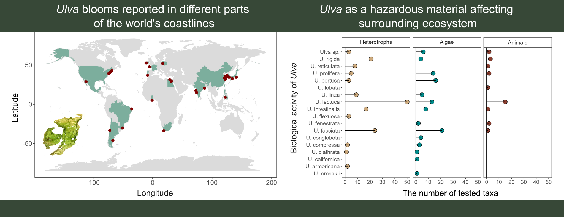

*Keywords*: economic losses; hazardous compounds; environmental threat; harmful bloom; Green Tides

**1. Introduction**

Aquatic green macroalgae *Ulva* is a genus that raises a lot of controversy. *Ulva* is a species that has recently been intensively promoted, especially in scientific journals focusing on the optimization and commercialization of new organisms for commercial purposes. Mass cultivation of *Ulva* sp. in outdoor open cultivation ponds of 1000 m2 can produce approximately 10 tons of dry biomass per year (Simon et al., 2022). *Ulva* sp. has gained recognition as a profitable food source, cosmetic product, or as an environmental bioremediation agent due to its ability to absorb large amounts of heavy metals and other hazardous pollutants (Mantri et al., 2020; Simon et al., 2022).

However, despite its nutritional and commercial benefits, *Ulva* sp. poses environmental and potential health risks that merit caution and consideration. Unfortunately, the lack of sufficient knowledge about the ecophysiology of *Ulva* sp. and unified rules and methods for obtaining biomass may lead to numerous abuses. For instance, it is possible to use *Ulva* biomass from sewage treatment plants or dead thallus obtained after bloom event as a source of cosmetics or food products. It has now become a fact that algae-based food supplements may be harmful to human health due to the high content of heavy metals including cadmium (Cd), lead (Pb), or mercury (Hg) (Rzymski et al., 2015).

It is well-established that *Ulva* sp. produces a diverse array of harmful secondary metabolites. Nevertheless, the extent of their hazardous effects on the surrounding ecosystem remains uncertain. Given the ability of *Ulva* sp. to inhibit the growth of competing algal and plant species, as well as to cause the mortality of various animal taxa, including vertebrates, an important question arises whether *Ulva* sp.is actually a safe and beneficial organism, or rather a threat to the environment.

Here, we reviewed the general classification and morphological differences of the *Ulva* genus and the locations of occurrence and physiological features that help this green algae adapt to changing environmental conditions. Next, we summarized available reports on the locations of *Ulva* sp. blooms in aquatic ecosystems and their broad consequences. We also presented the most frequently used methods for testing the biological activity of *Ulva* sp. and their active compounds that affect the surrounding ecosystem. At the end, we compiled reports on the harmful effects of *Ulva* on viruses, bacteria, fungi, micro- and macroalgae, as well as invertebrates and vertebrates. This article highlights the need for interdisciplinary research aimed at shedding light on the basic mechanisms governing the occurrence and succession of green algae in coastal seas as well as drawing the attention of the public to the fact that *Ulva* sp. is an organism that poses a real threat to the functioning of the aquatic environment and causes financial damage in a global scale.

**2. Classification and morphology of *Ulva* sp.**

The genus *Ulva* was first described by Carolus Linnaeus in *Species Plantarum* (Linnaeus, 1753). In modern classification, *Ulva* belongs to the phylum Chlorophyta, class Ulvophyceae (K.R. Mattox & K.D. Stewart), order Ulvales (Blackman & Tansley), and family Ulvaceae (J.V. Lamouroux ex Dumortier) (Guiry & Guiry, 2024). Phylogenetic studies have merged *Ulva* and *Enteromorpha* into a single genus (Hayden et al., 2003; Shimada et al., 2003), with 102 taxonomically accepted species worldwide (Guiry & Guiry, 2024). The most commonly occurring *Ulva* species are shown in Fig. 1.

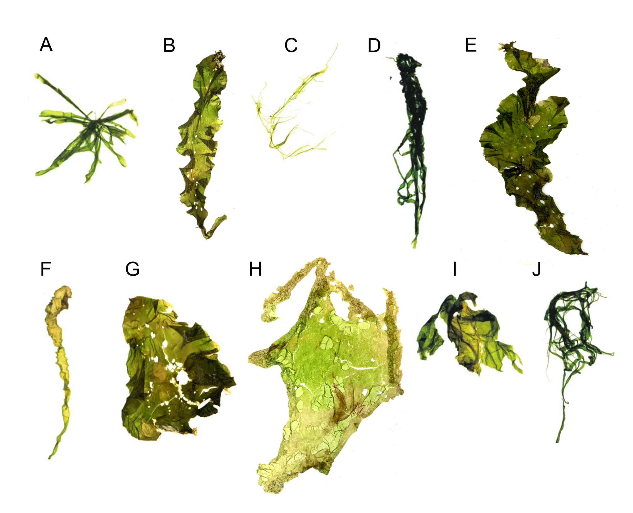

**Fig. 1.** Morphology of common *Ulva* species: (A) *Ulva compressa*; (B) *Ulva fasciata*; (C) *Ulva flexuosa*; (D) *Ulva intestinalis*; (E) *Ulva* *lactuca*; (F) *Ulva linza*; (G) *Ulva* *lobata*; (H) *Ulva ohnoi*; (I) *Ulva prolifera*; (J) *Ulva rigida*.

Historically, species identification relied on morphological and anatomical traits, including thallus shape and size, presence of dentation, thickness, cell structure, and number of pyrenoids. However, these characteristics can be highly variable due to factors such as age, reproductive state, grazing pressure, and environmental conditions (Guiry & Guiry, 2024). Consequently, molecular markers are increasingly used for taxonomic classification, leading to the discovery of new free-floating *Ulva* species associated with Green Tides (Kazi et al., 2016; Kang et al., 2021; Wan et al., 2017; Krupnik et al., 2018).

The mature *Ulva* sp. thallus consists of a flattened, distromatic blade, where two layers of independent but closely associated cells form the structure. Thallus morphology varies widely, ranging from broad, irregularly lobed blades to linear, lanceolate, or oblanceolate shapes. Some species, such as *U. reticulata*, have perforated blades, while others, like *U. rigida*, *U. scandinavica*, and *U. taeniata*, remain unperforated. The thallus can grow up to one meter under optimal conditions (Guiry & Guiry, 2024). Pigmentation varies from dark green to pale yellow, and vegetative cells contain a single chloroplast and one or more pyrenoids. Starch content, which serves as a reserve material, fluctuates between 1.59% and 21.44%, depending on growth conditions and seasonality (Kazir et al., 2021).

Morphological variation in *Ulva* sp. is influenced not only by physical and chemical environmental factors but also by microbial associations. Major bacterial groups such as Bacteroidetes and Planctomycetes colonize *U. australis* surfaces (Tujula, 2006), and similar bacterial communities have been found in *Ulva* sp. from different habitats (Goecke et al., 2010). The interaction between *Ulva* sp. and bacteria is crucial for normal morphological development. In axenic culture, *Ulva* sp. loses its typical form, but co-cultivation with bacterial isolates restores its normal structure (Provasoli & Pintner, 1980). Spoerner et al. (2012) demonstrated that regulatory compounds secreted by *Cytophaga* MS6 (with auxin-like activity) and *Roseobacter* MS2 (with cytokinin-like activity) influence the growth and morphogenesis of *U. mutabilis*.

**3. Occurrence and physiology of *Ulva* sp.**

*Ulva* sp. is a cosmopolitan genus found in oceans and estuaries worldwide (Guiry & Guiry, 2024). Its successful colonization across diverse environments is attributed to physiological, biochemical, and molecular adaptations. *Ulva* sp. is distributed across all seven continents, including Antarctica. Asia records the highest species diversity with 56 species, followed by Australia (40 species), Europe (38 species), North America (34 species), Africa (31 species), South America (20 species), and Antarctica (12 species) (Mantri et al., 2020).

The broad distribution of *Ulva* sp. is due to its remarkable tolerance and adaptation to key environmental factors such as light, temperature, and salinity. It can thrive in both freshwater and marine habitats. Marine species typically inhabit coastal zones to depths of 40 meters (Chapman, 1956), while freshwater species have been documented in central Europe (e.g., *Ulva flexuosa*; Rybak, 2015) and on Japan's Ryukyu Islands (*Ulva limnetica*; Ichihara et al., 2009). Additionally, species like *Ulva lactuca*, *Ulva rigida*, *Ulva compressa*, and *Ulva pertusa* can tolerate salinity gradients ranging from less than 0.5 to 49 PSU (Hofmann et al., 2010). Seasonal growth patterns show increased abundance during spring and summer, as warmer temperatures enhance growth and reproduction (Caniguan et al., 2025; Uchimura et al., 2004). For instance, the optimal temperature for spore/gamete release and growth in *U. prolifera* is 20–27°C (Wang et al., 2007), with blooms typically occurring at 23–26°C (Li et al., 2018). Moreover, *Ulva* sp. exhibits a linear growth response to light intensity up to 30 μmol photons m−2s−1, reaching saturation above 70 μmol photons m−2s−1 (Fortes & Lüning, 1980). Its opportunistic nature—marked by rapid nutrient uptake and fast growth rates—can lead to explosive increases in biomass (Melton et al., 2016; Hu et al., 2017). Wu et al. (2022) noted that the formation of air sacs in *Ulva* is influenced by adaptive changes in temperature and light, while settlement in *U. prolifera* is triggered by temperatures exceeding the optimal range.

*Ulva* sp. reproduces both sexually and asexually. Its sexual cycle is characterized by an isomorphic alternation of generations, with morphologically similar but genetically distinct sporophyte and gametophyte phases. In addition, *Ulva* sp. can reproduce asexually through biflagellate zoospores and by parthenocarpy, enhancing its reproductive versatility (Mantri et al., 2020). The haploid thallus typically contains between 5 and 13 chromosomes (Guiry & Guiry, 2024).

Adaptation of the light-harvesting pigments is another key physiological feature. *Ulva* sp. contains chlorophyll a along with accessory pigments such as chlorophyll b and carotenoids (see Fig. 2). Recent analyses of absorption spectra and chromatographic retention times have confirmed the presence of carotenoids including lutein, β-carotene, neoxanthin, β-cryptoxanthin, violaxanthin, antheraxanthin, and zeaxanthin, although total pigment yield varies with species (Eismann et al., 2020).

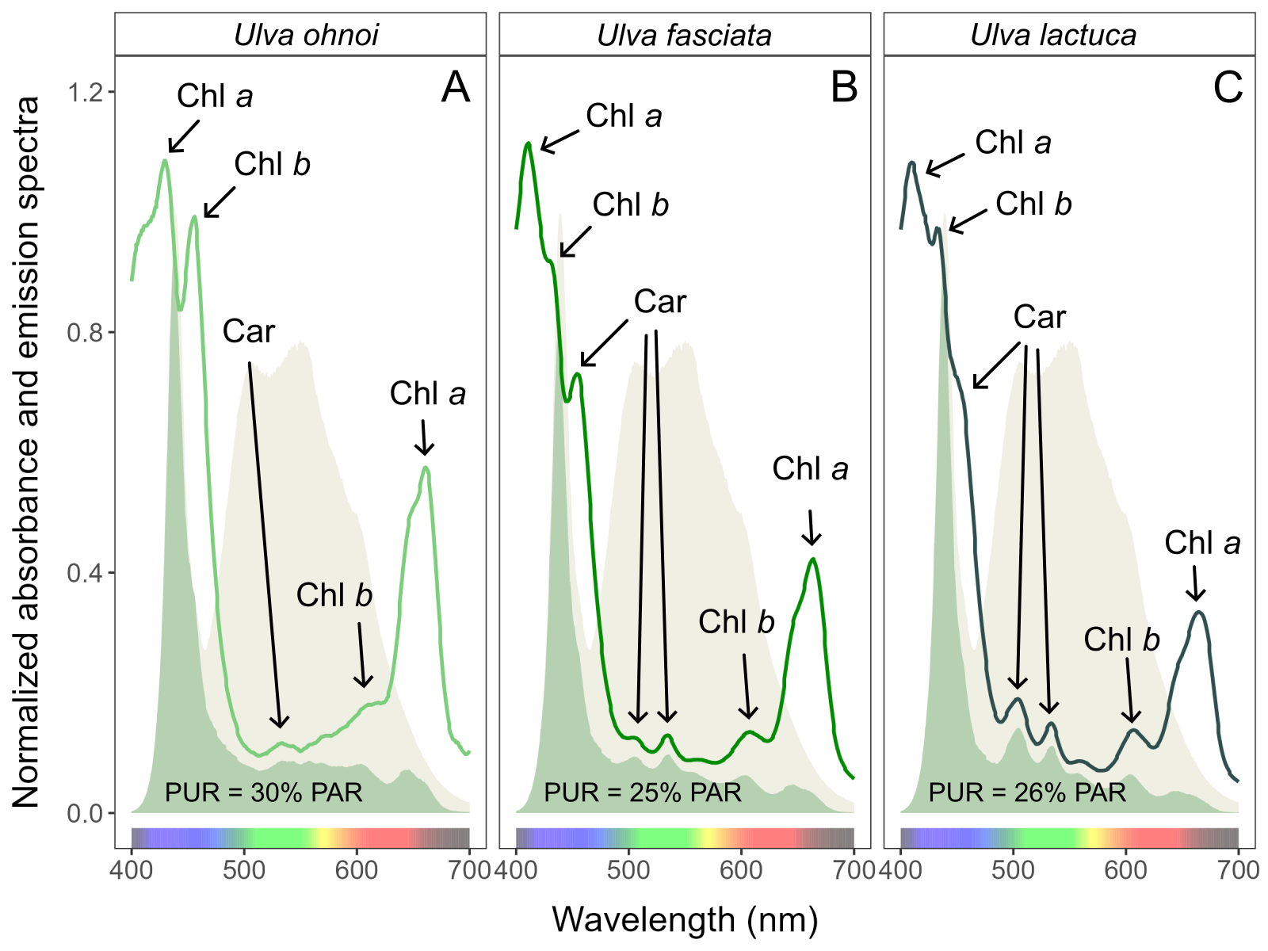

**Fig. 2.** Whole-cell absorbance spectra of (A) *Ulva ohnoi*; (B) *Ulva fasciata*; (C) *Ulva lactuca*, together with emission spectra of the white LED lamp (yellow area), normalized to emission at 440 nm, and PUR (green area). Peaks characteristic of known pigments are labeled: Chl *a*, chlorophyll *a*; Chl *b*, chlorophyll *b*; Car, carotenoids.

**4. Prevalence and consequences of *Ulva* sp. blooms**

*Ulva* sp. is notorious for its rapid and uncontrolled proliferation, leading to phenomena known as Green Tides. Although these blooms share common traits, they vary widely in location, causative organisms, triggers, and impacts. Green Tides affect diverse sites and impose significant economic and environmental burdens, drawing attention from both scientists and policymakers (Ye et al., 2011). In addition to adversely impacting tourism (Villares et al., 1999), large algal mats can create a hostile physico-chemical environment. These mats may blanket surfaces, alter sediment chemistry (Raffaelli et al., 1989; Gamenick et al., 1996; Valiela et al., 1997), induce sulfide poisoning (Gamenick et al., 1996), and generate anoxic conditions at the water-sediment interface (Norkko et al., 2000). They can also modify bird feeding behaviors (Raffaelli et al., 1989), smother seagrass beds (den Hartog, 1994), and interfere with water use due to floating masses of detached algae. Additionally, they cause aesthetic issues such as odor nuisances and fouling of bathing waters (Montgomery et al., 1978; Charlier et al., 2008), and can alter benthic algal communities (Munda, 1993; Worm et al., 2001).

The frequency of massive Green Tides has increased worldwide (Smetacek & Zingone, 2013; see Fig. 3). Until 1999, *Ulva* sp. blooms were primarily recorded in Europe, the USA, South Africa, and Japan. Over the past 25 years, however, these blooms have spread significantly, with only Australia and Antarctica yet to report such events (see Fig. 3 and Table 1). The dispersal of free-floating thallus fragments can initiate new blooms in previously unaffected areas, posing serious ecological and economic challenges. Notably, newly identified species such as *U. pseudo-ohnoi* sp. nov. have also been implicated in massive bloom events (Lee et al., 2019).

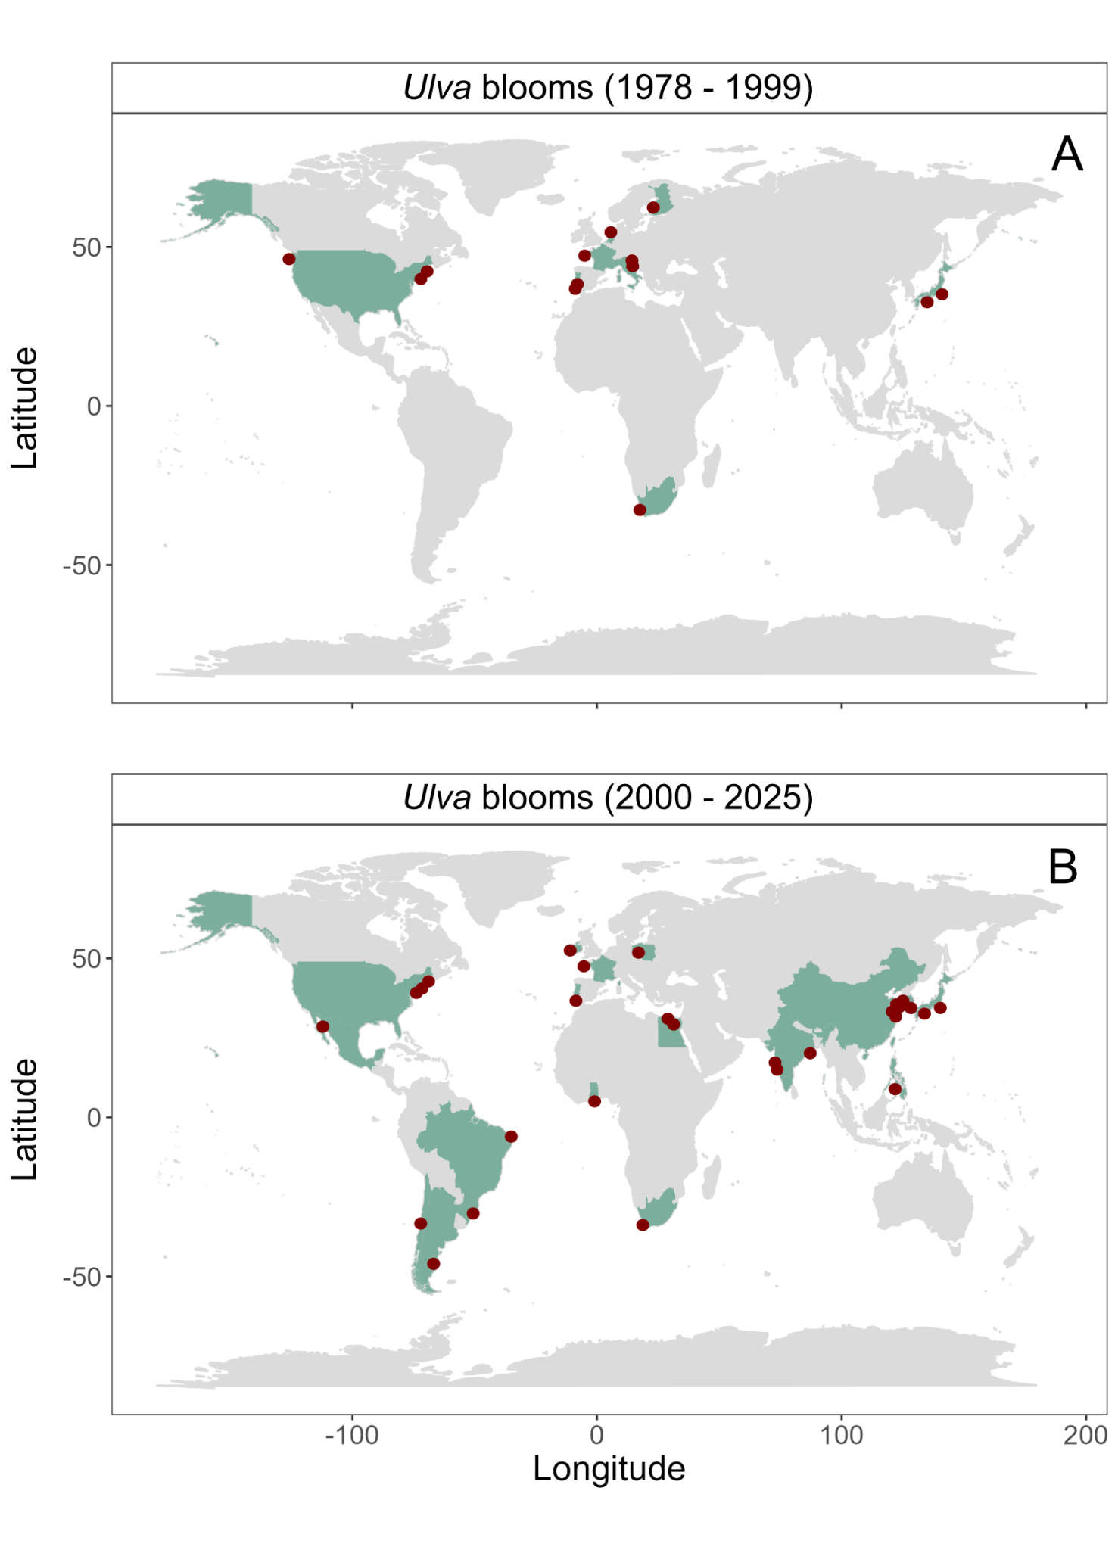

**Fig. 3.** Countries (green area), and specific places (red circles) where *Ulva* blooms were recorded before (top panel; A) and after (bottom panel; B) 2000.

Multiple factors contribute to the formation and persistence of *Ulva* sp. blooms. The widespread distribution of both microscopic and macroscopic stages of *Ulva* sp. plays a role in the global outbreak of Green Tides (Teichberg et al., 2010; Jones et al., 2020). Excess nutrient inputs from agricultural runoff or wastewater discharge, combined with eutrophication, create ideal conditions for bloom formation (Teichberg et al., 2010). Additionally, the high surface-to-volume ratio of *Ulva* sp. enhances its rapid growth (Van Alstyne et al., 2015), and conditions such as brackish salinity and a pH near 7.0 have been linked to significant increases in biomass (Lin et al., 2011).

Green Tides have become a major concern for scientists, environmental organizations, and policymakers striving to mitigate their impacts on marine ecosystems and coastal communities. These large-scale blooms, particularly prevalent in nutrient-rich coastal areas (Kang & Chung, 2017), can alter light availability for phytoplankton and benthic communities over prolonged periods (Malta et al., 2003). For example, in the Venice Lagoon, a period of intense *Ulva* growth in the late 1980s was followed by a subsequent decline, which dramatically altered local conditions (Charlier et al., 2008). Furthermore, as *Ulva* biomass decomposes and sinks, oxygen depletion can lead to localized hypoxic "dead zones" (Hu & He, 2008).

Economic damages from *Ulva* sp. blooms are also significant. For instance, blooms of *U. lactuca* in coastal waters near urbanized and agricultural regions like Maui, Hawaii, result in annual losses exceeding 20 million dollars (Van Beukering & Cesar, 2004; Dailer et al., 2012). In Brittany, France, a Green Tide event led to the accumulation of 100,000 tonnes of *Ulva* biomass (primarily *U. armoricana* and *U. rotundata*), costing an estimated US$10–150 per tonne in cleaning and disposal expenses (Charlier et al., 2008). Similarly, in 2008, a 30-kilometer-long bloom of *U. prolifera* along the Qingdao coast in China required the disposal of over 1 million tonnes of biomass at a cost of US$30 million, employing 10,000 individuals (Ye et al., 2011; Shi et al., 2015; Mantri et al., 2020). The emergency response costs prior to the 2008 Beijing Olympic Games sailing competition in Qingdao were estimated at around 200 million euros, amounting to 5.84% of Qingdao Municipality's total income for that year (Berdalet et al., 2016).

**Table 1.**

Examples of *Ulva* sp. blooms reported in different parts of the world's coastlines.

|  |  |  |  |
| --- | --- | --- | --- |
| ***Ulva* species** | **Bloom location (country)** | **Year of bloom** | **Reference** |
| **Asia** | | | |
| *U. prolifera* | Yellow Sea (China) | 2021 | Dong et al. (2023) |
| *U. prolifera* | Yellow Sea (China) | 2022 | Cai et al. (2025) |
| *Ulva* sp. | Yellow Sea (China) | 2023 | Zhang et al. (2024) |
| *Ulva* sp. | Yellow Sea (China) | 2008 - 2009 | Liu et al. (2010) |
| *Ulva meridionalis* | Yingkou (China) | 2021 | Lü et al. (2022) |
| *U. prolifera* | Yellow Sea (China) | 2007 - 2024, 2007 - 2018, 2007 - 2013 | Gong et al. (2024), Xia et al. (2024), Zhang et al. (2019), Xu et al. (2014) |
| *U. prolifera* | Shanghai (China) | 2021, 2023 | Liu et al. (2025) |
| *U. meridionalis* | Changhua County, (Taiwan) | 2023 | Su et al. (2025) |
| *U. prolifera* | Jiangsu and Shandong (China) | 2021 | Feng et al. (2024) |
| *U. prolifera* | Yellow Sea, Qingdao (China) | 2008 - 2015 | Qi et al. (2016) |
| *U. prolifera* | Yellow Sea, Qingdao (China) | 2015 | Hu et al. (2024) |
| *Ulva* sp. | Tawi-Tawi Islands (Philippines) | 2015 | Abduraup et al. (2025) |
| *U. prolifera* | Qingdao, Rizhao, Haiyang (China) | 2023 | Liu et al. (2024) |
| *U. pertusa,*  *Ulva* sp. | Hiroshima Bay (Japan) | 2000 - 2001 | Yoshida et al. (2015) |
| *U. ohnoi,*  *U. pertusa* | Jeju Island (South Korea) | 2020 - 2022 | Choi et al. (2024) |
| *U. ohnoi* | Jeju Island (South Korea) | 2017 - 2018, 2018 | Samanta et al. (2019), Kang et al. (2021) |
| *U. australis,*  *U. lactuca,*  *U. laetevirens,*  *U. ohnoi,*  *U. pseudo-ohnoi, Ulva* sp. | Jeju Island (South Korea) | 2017 - 2018 | Lee et al. (2019) |
| *Ulva* sp. | Tokyo Bay (Japan) | 1984- 1985, 1991, 1995 - 2007 | Yabe et al. (2009) |
| *U. intestinalis* | Goa, Karnataka, Kerala (India) | 2012 | Bast et al. (2014) |
| *U. compressa* | Karnataka (India) | 2012 | Bast et al. (2014) |
| *U. lactuca* | Bay of Bengal (India) | 2023 | Peter et al. (2024) |
| **Europe** | | | |
| *Ulva* sp. | Sacca di Goro lagoon, Adriatic Sea, (Italy) | 1987 - 1998 | Viaroli et al. (2005a), Viaroli et al. (2005) |
| *Ulva* sp. | Bay of Brest (France) | 1998 - 2000 | Ménesguen et al. (2006) |
| *Ulva* sp. | Hillion (France) | 1989 - 1992 | Charlier et al. (2008) |
| *Ulva* sp. | Brittany coast (France) | 1978 - 2008, 2012,  2003 - 2020 | Ménesguen et al. (2010), Louis et al. (2023), Jones et al. (2020) |
| *Ulva* sp. | Algarve region (Portugal) | 2021 | Herrero et al. (2023) |
| *Ulva* sp. | Ria Formosa (Portugal) | 1996 - 1997 | Aníbal et al. (2007) |
| *U. flexuosa* | (Poland) | No information | Rybak and Gąbka (2018) |
| *Ulva* sp. | Mondego Estuary (Portugal) | 1993 - 1995 | Martins et al. (2001) |
| *Ulva* sp. | Veerse Meer (Netherlands) | 1992, 1994, 1997 | Malta and Verschuure (1997), Malta et al. (2003) |
| *Ulva* sp.  *U. rigida* | Venice lagoon (Italy) | 1970 - 1980, 1988 | Runca et al. (1996) |
| *Ulva sp.* | Venice lagoon (Italy) | 1987 | Sfriso et al. (1989) |
| *U. rigida,*  *U. rotundata,*  *Ulva* sp. | Ireland | 2010 | Wan et al. (2017) |
| *Ulva* sp. | Irish Sea and Atlantic Ocean (Ireland) | 2016 - 2017 | Bermejo et al. (2019) |
| *U. intestinalis* | Baltic Sea (Finland) | 1993 - 1997 | Back et al. (2000) |
| **North America** | | | |
| *Ulva* sp. | New Haven (USA) | 2023 | Xing et al. (2024) |
| *U. lactuca* | New Jersey (USA) | 2004 - 2010 | Kennish et al. (2011) |
| *Ulva* sp. | Narragansett Bay, Rhode Island (USA) | 1996 - 1997 | Granger et al. (2000) |
| *U. compressa,*  *U. rigida* | Narragansett Bay, Rhode Island (USA) | 2009 - 2011 | Guidone and Thornber (2013) |
| *U. rigida,*  *U. acanthophora,*  *Ulva* sp. | Gulf of California (Mexico) | 2013 - 2015 | Chávez-Sánchez et al. (2017) |
| *Ulva* sp. | Washington State (USA) | 1998 - 2000 | Nelson et al. (2003) |
| **South America** | | | |
| *U. stenophylloides, U. uncialis* | Algarrobo Bay (Chile) | 2023 | Mutizabal-Aros et al. (2024a) |
| *U. stenophylloides,*  *U. uncialis,*  *U. australis, U. compressa,*  *U. aragoensis* | Algarrobo Bay (Chile) | 2021 - 2023 | Mutizabal-Aros et al. (2024b) |
| *U. lactuca* | Macau and Porto do Mangue (Brazil) | 2008 - 2023 | Puppin-Gonçalves et al. (2024) |
| *Ulva* sp. | Patos Lagoon Estuary  (Brazil) | 2004 - 2007 | Lanari and Copertino (2017) |
| *U. lactuca* | San Antonio Bay (Argentina) | 2017 | Becherucci et al. (2021) |
| **Africa** | | | |
| *U. lactuca* | Knysna Estuary (South Africa) | 2015 | Human et al. (2016) |
| *U. lactuca* | Saldanha Bay (South Africa) | 1993 - 1994 | Anderson et al. (1996) |
| *Ulva* sp.  *U. lactuca* | Knysna Estuary (South Africa) | 2015 | Allanson et al. (2016) |
| *U. fasciata* | Qaitbay (Egypt) | 2018 | Hosny et al. (2022) |
| *U. pertusa,*  *U. lactuca* | El Garabaa at North El-Manzala Lake, and River Nile estuary at Damietta (Egypt) | 2019 | Ahmed et al. (2021) |
| *U. clathrata* | Ankobra River (Ghana) | 2011 | Granger et al. (2012) |

**5. Methods of testingbioactivity of *Ulva* sp.**

To assess the impact of *Ulva* sp. on other organisms, researchers employ a variety of investigative approaches. Common methods include adding extracts, conducting experiments with fresh thalli, performing co-culture assays, and carrying out field observations. In many studies, several methods are applied simultaneously for comparative analysis.

The most frequently used technique involves preparing extracts from dried *Ulva* sp. thalli. In this approach, a dry sample is ground and mixed with distilled water, seawater, or chemical reagents, followed by high-speed centrifugation or filtration. A specific dose of the resulting extract is then introduced to the target organism. A second method involves the use of cell-free filtrates. In this procedure, *Ulva* sp.—with a known biomass and maintained under controlled conditions—is cultivated for several days. The thalli are then removed, and the filtrate, containing bioactive compounds, is used to inoculate cultures of the target organisms. A third approach is the direct inoculation of fresh *Ulva* sp. thalli into cultures of the test organisms (Jin & Dong, 2003; Jin et al., 2005; Nan et al., 2008; Cai et al., 2011; Wang et al., 2012; Renjun et al., 2013; Accoroni et al., 2015; Lv et al., 2021; Salama et al., 2021). Additionally, isolation co-culture assays have been employed by Wang et al. (2006) and Jin and Dong (2003), whereby direct contact between the target species and *Ulva* sp. is prevented. Mesocosm experiments, using floating tanks deployed at the sampling site, allow *Ulva* sp. to be maintained under ambient conditions similar to its natural habitat (Tang & Gobler, 2011). Tang and Gobler (2011) also conducted bottle incubation experiments as part of their field studies.

**5. The effect of *Ulva* sp. on surrounding ecosystem**

Evidence indicates that *Ulva* sp. exhibits significant bioactivity against a variety of heterotrophic microorganisms, microalgae, seaweeds, grazers, and other animals. Most research has focused on species such as *Ulva lactuca*, *U. fasciata*, and *U. rigida* (see Fig. 4), with a detailed summary provided in the Supplementary Materials.

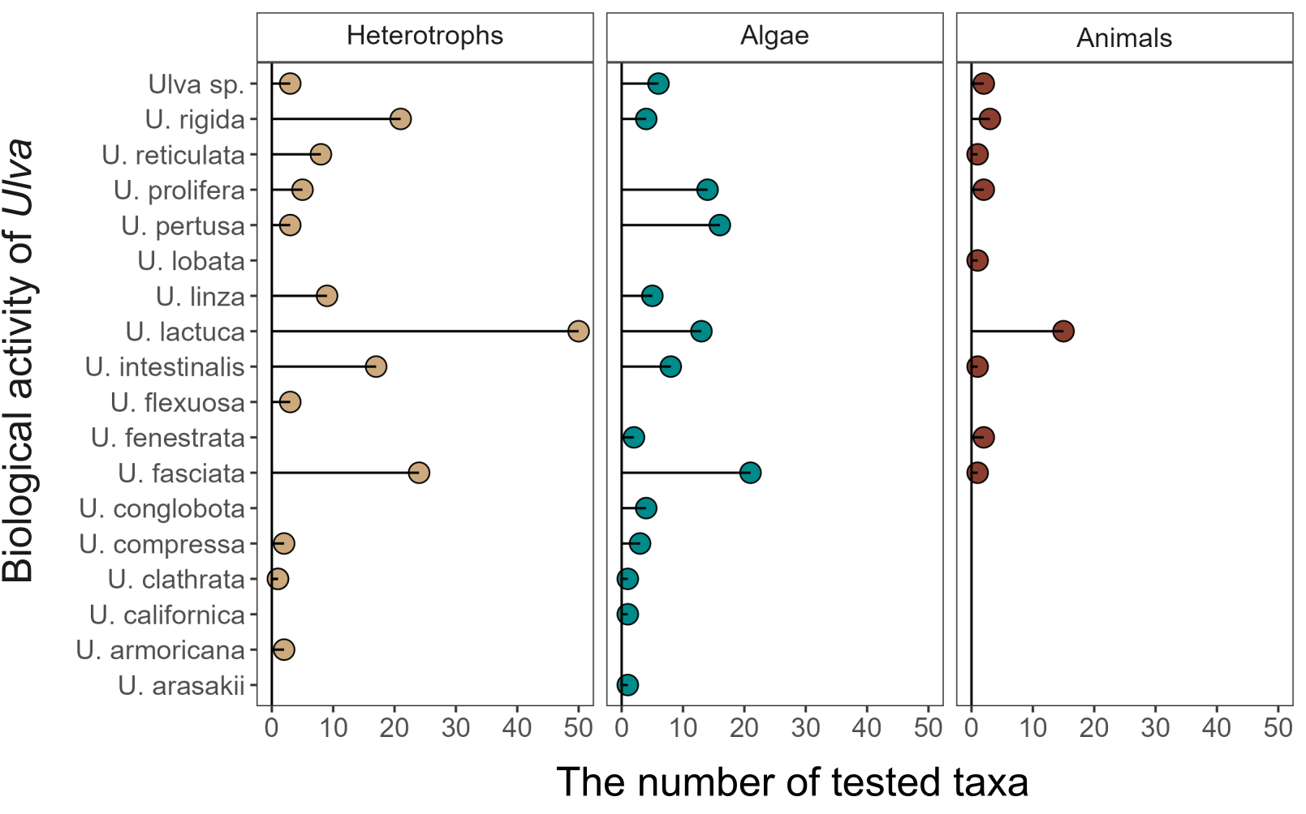

**Fig. 4.** Number of viruses, heterotrophic bacteria, fungi (Heterotrophs), micro- and macroalgae (Algae), invertebrates and vertebrates (Animals) affected by *Ulva* genus.

*5.1 Ulva sp. as a hazardous material affecting heterotrophic microorganisms*

Research has demonstrated that various *Ulva* species can impact viruses, bacteria, and fungi (Figs. 4–7). Studies have documented effects on 20 different virus types, 22 heterotrophic bacterial types, and 28 fungal taxa, with *Ulva lactuca* being the most extensively tested—against 50 different taxa of heterotrophic microorganisms. Generally, these studies report a strongly or moderately inhibitory effect of *Ulva* compounds on microbial development. Notably, only certain species within the *Aspergillus* genus have exhibited growth stimulation under the influence of compounds secreted by *Ulva lactuca* (see Fig. 7). Frequently tested bacteria include strains of *Bacillus*, *Escherichia*, and *Staphylococcus* (Fig. 6). Recent research also indicates that *Ulva* can actively inhibit viruses, including SARS-CoV-2 (Fig. 5).

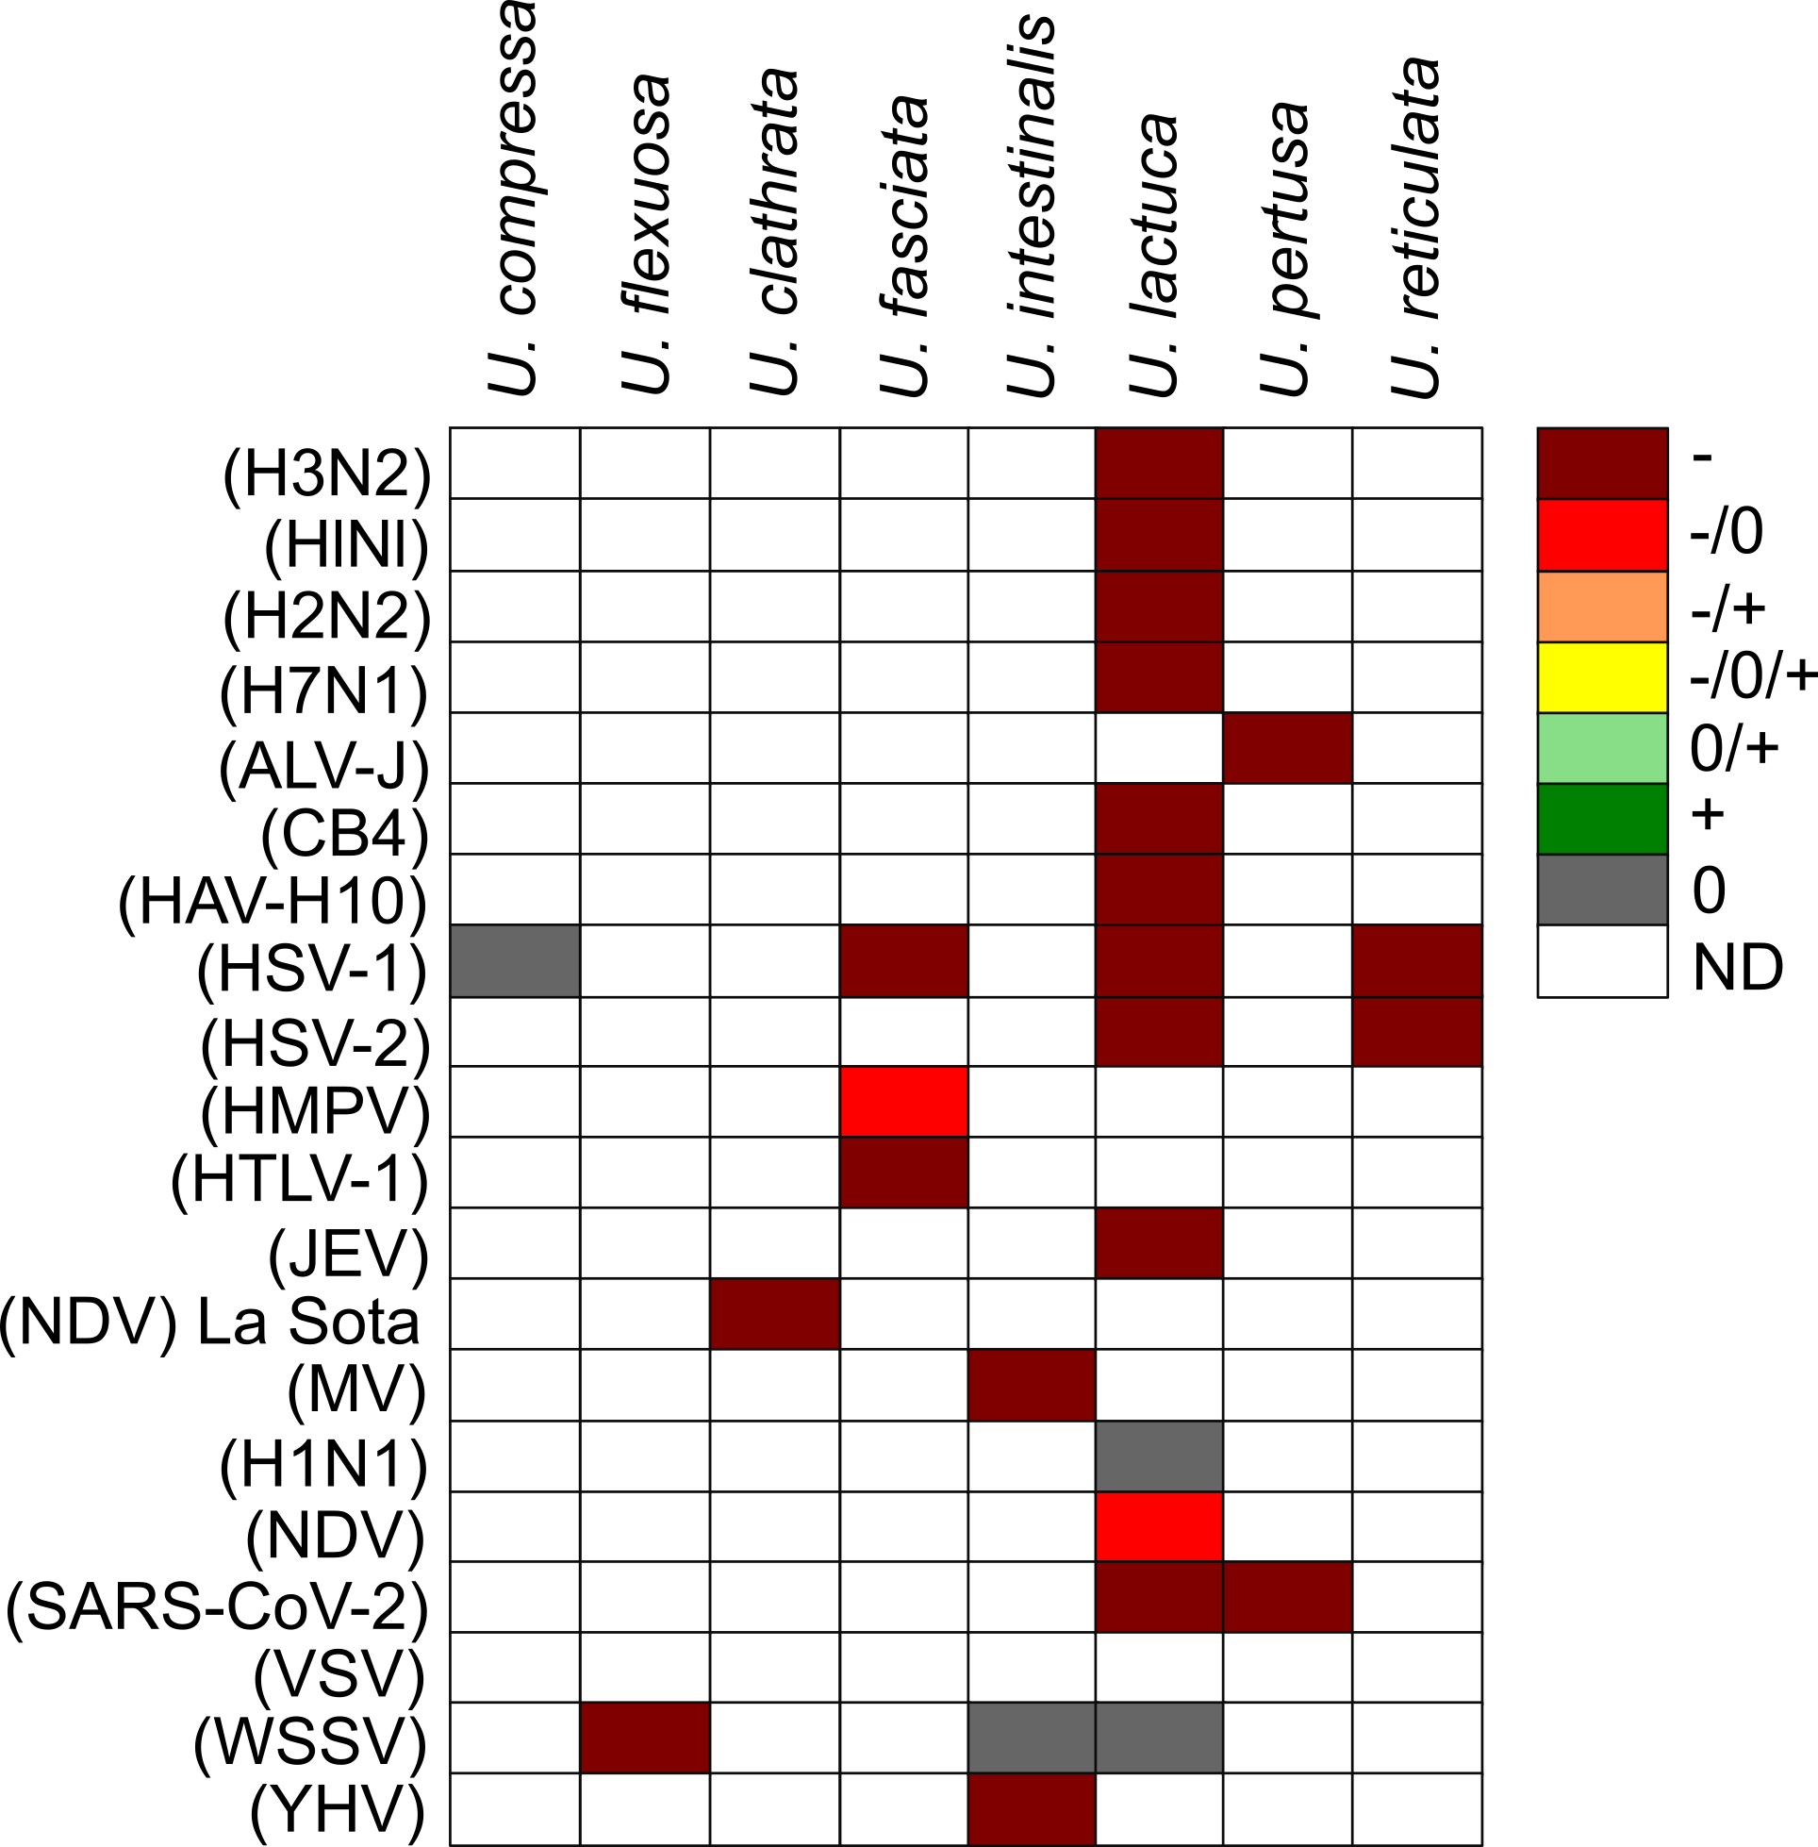

**Fig. 5.** The biological activity of *Ulva* against viruses.

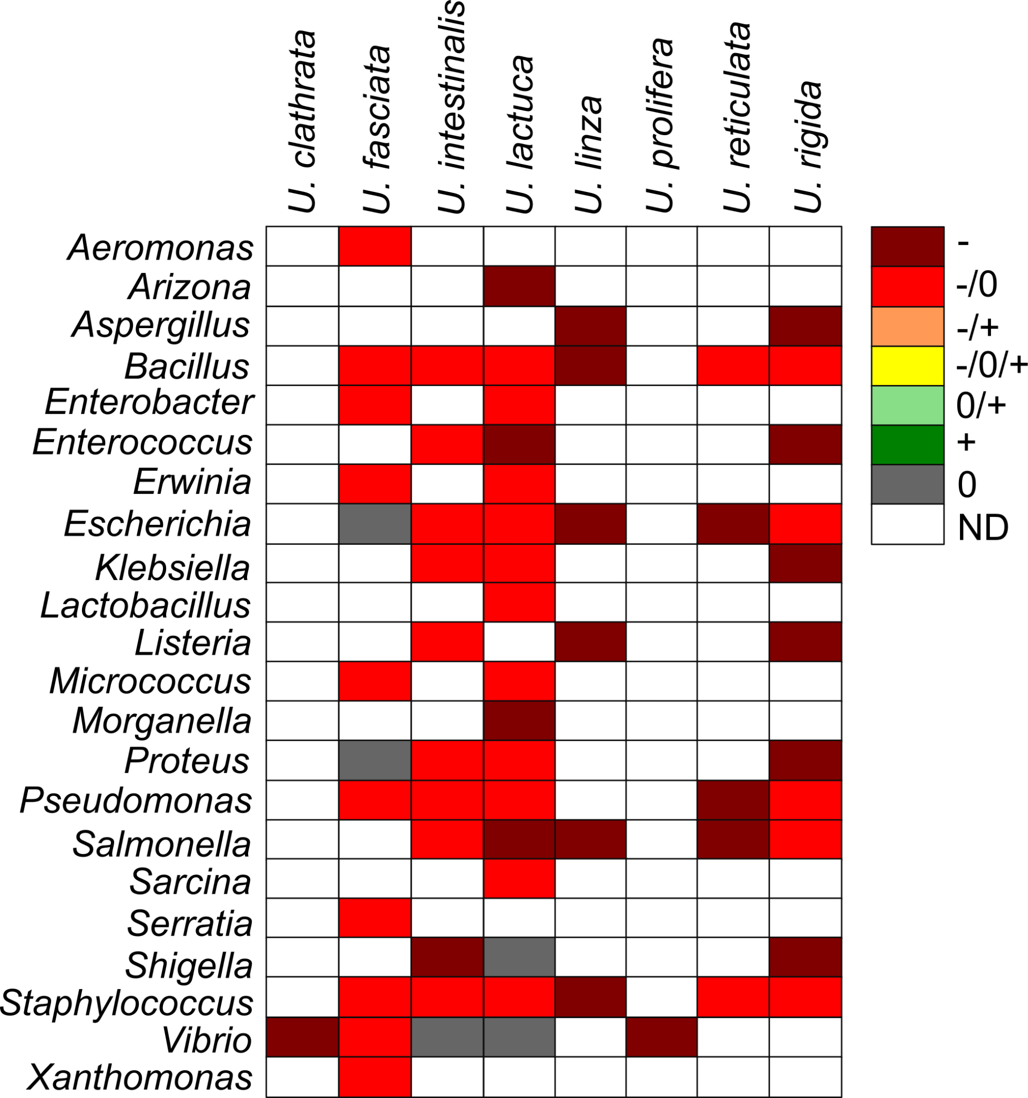

**Fig. 6.** The biological activity of *Ulva* sp. against bacteria.

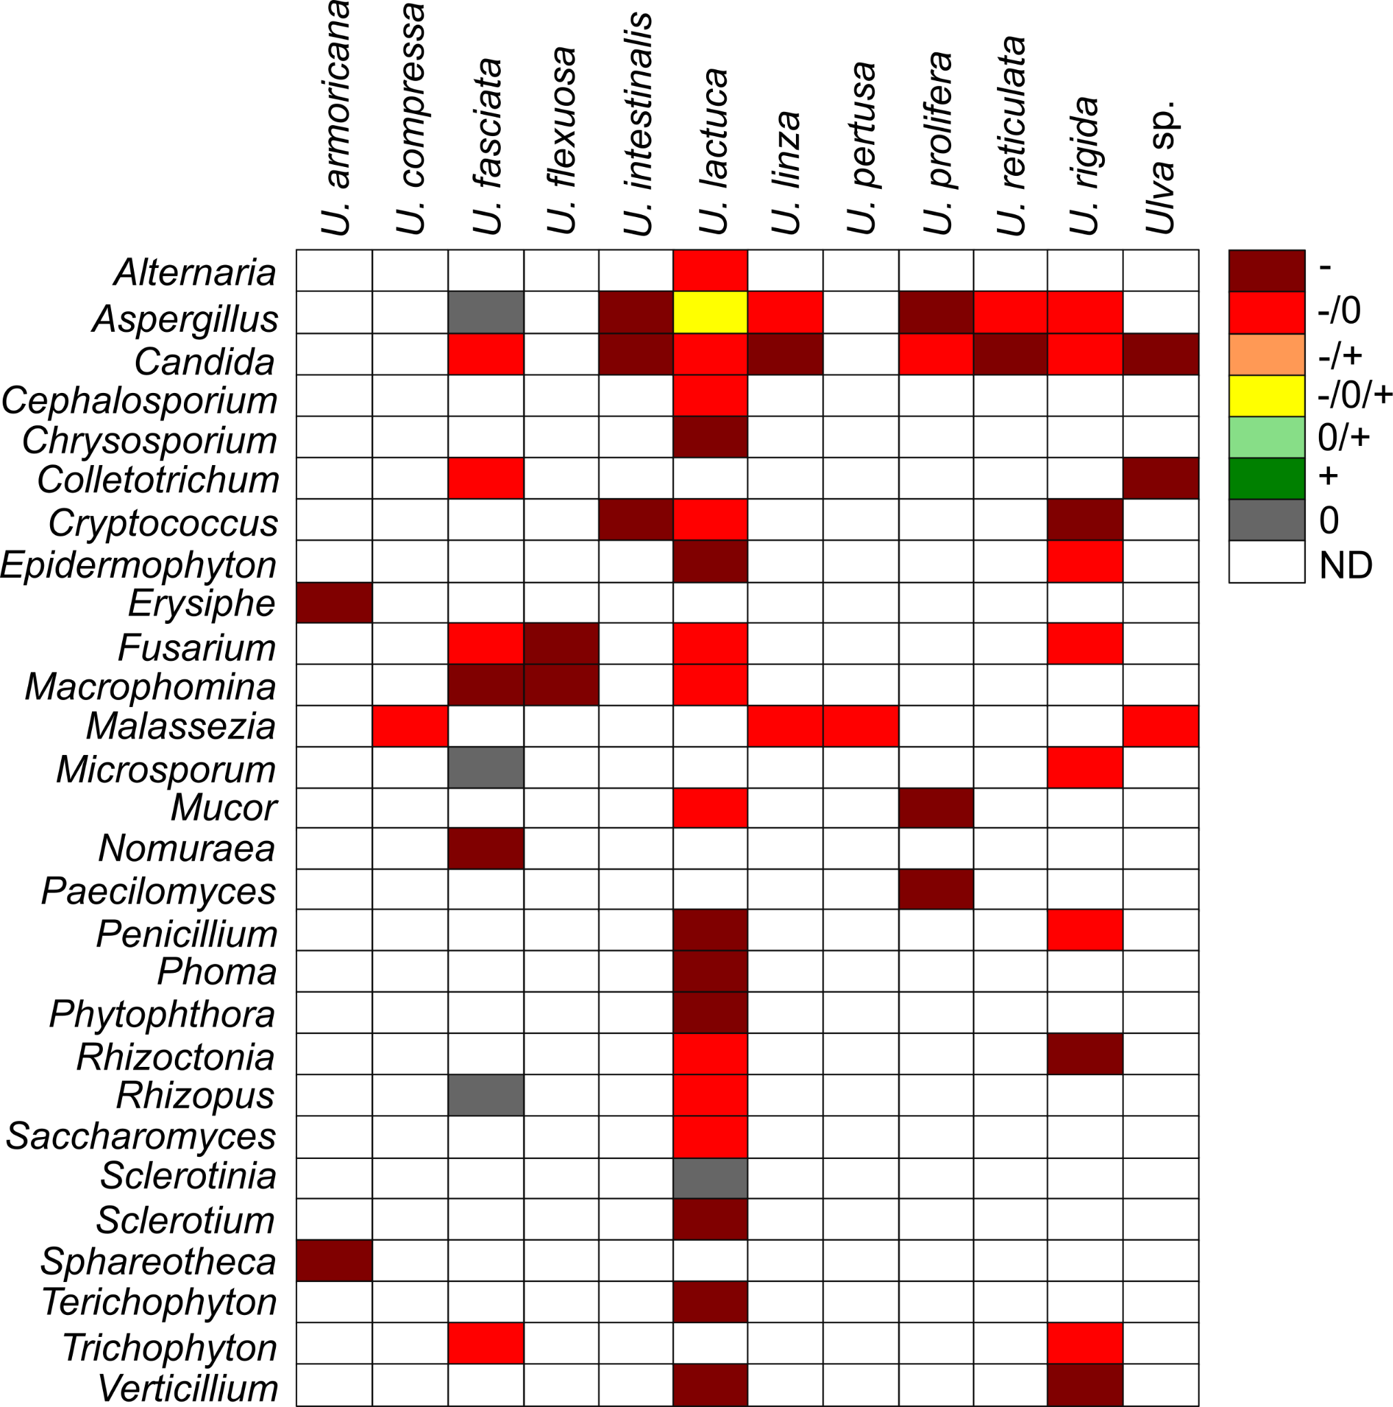

**Fig. 7.** The biological activity of *Ulva* sp. against fungi.

*5.2 Ulva sp. as a hazardous material affecting microalgae and seaweeds in the aquatic environment*

Our comparative analysis reveals that both micro- and macroalgae constitute the largest group of organisms evaluated for the effects of *Ulva* compounds (Fig. 8). Testing has encompassed 21 taxa within Dinoflagellata, 17 within Heterokontophyta, 13 within Chlorophyta, 7 within Rhodophyta, 3 each from Cyanobacteria and Haptophyta, and single taxa from the Cryptista and Euglenophyta classes. The majority of these organisms exhibit strong to moderate growth inhibition. Although a few studies suggest that *Ulva* may negatively affect marine vascular plants such as *Zostera* (Olyarnik & Stachowicz, 2012), some reports indicate that compounds secreted by *Ulva* can positively influence terrestrial crops and vegetables; however, these effects appear to be of limited ecological significance.

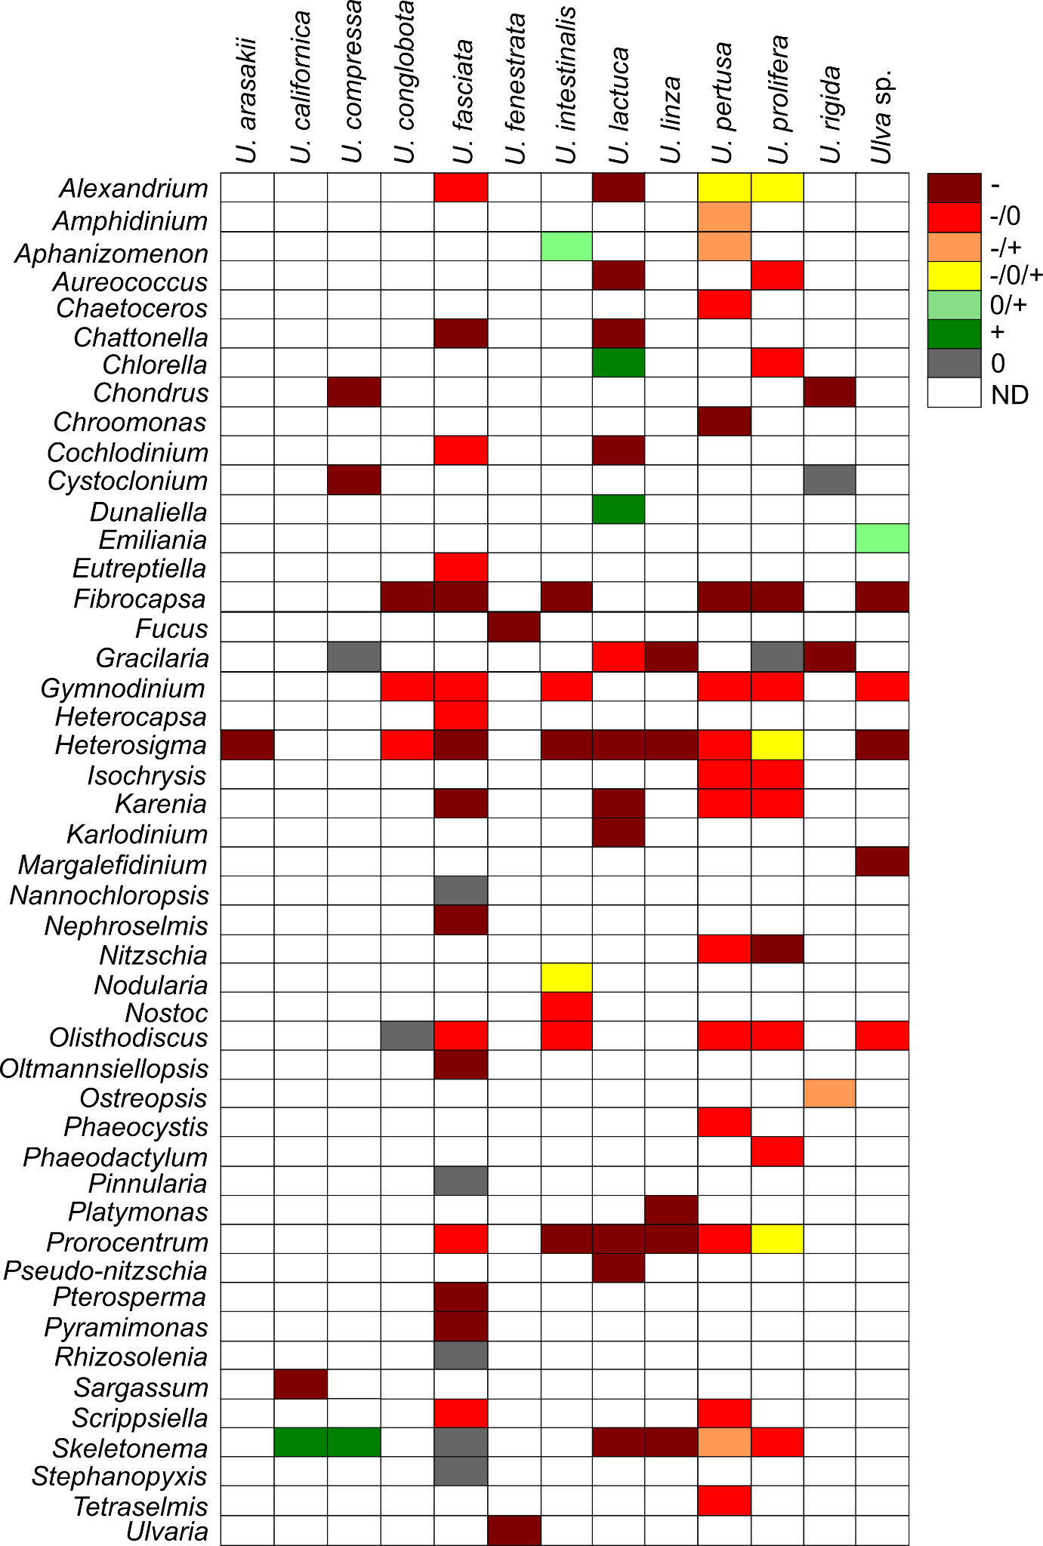

**Fig. 8.** The biological activity of *Ulva* sp. against microalgae and macroalgae.

*5.3 Ulva sp. as a hazardous material affecting invertebrates and vertebrates*

Research indicates that *Ulva* sp. secretes compounds that adversely affect the development and physiology of various invertebrates and vertebrates (Figs. 4, 9; see Supplementary Materials). Investigations have covered seven animal phyla: 14 taxa from Arthropoda, 8 from Mollusca, 4 from Chordata, and one taxon each from Rotifera, Echinodermata, Porifera, and Platyhelminthes. The majority of these studies report growth inhibition or mortality following exposure to *Ulva*-derived compounds. However, some taxa, including *Artemia*, *Brachionus*, *Cebidichthys*, *Inimicus*, and *Sparus*, have shown resistance. Conversely, species such as *Danio*, *Haliotis*, and *Litopenaeus* may experience growth stimulation under the influence of compounds from certain *Ulva* genera.

Additionally, *Ulva* sp. is typically free of macroinvertebrate colonization due to the production of antifouling agents in the thallus boundary layer. These waterborne toxic macromolecules originate both from the thalli and their associated epibiotic bacteria (Harder et al., 2004). For example, *U. reticulata* secretes bioactive substances, supplemented by bacterial compounds, to repel fouling organisms (Dobretsov & Qian, 2002; Harder et al., 2004). Egan et al. (2000) further reported that bacteria on the surface of *U. lactuca* inhibit the growth of bacteria, fungi, invertebrate larvae, and microalgae, although research in this area remains limited.

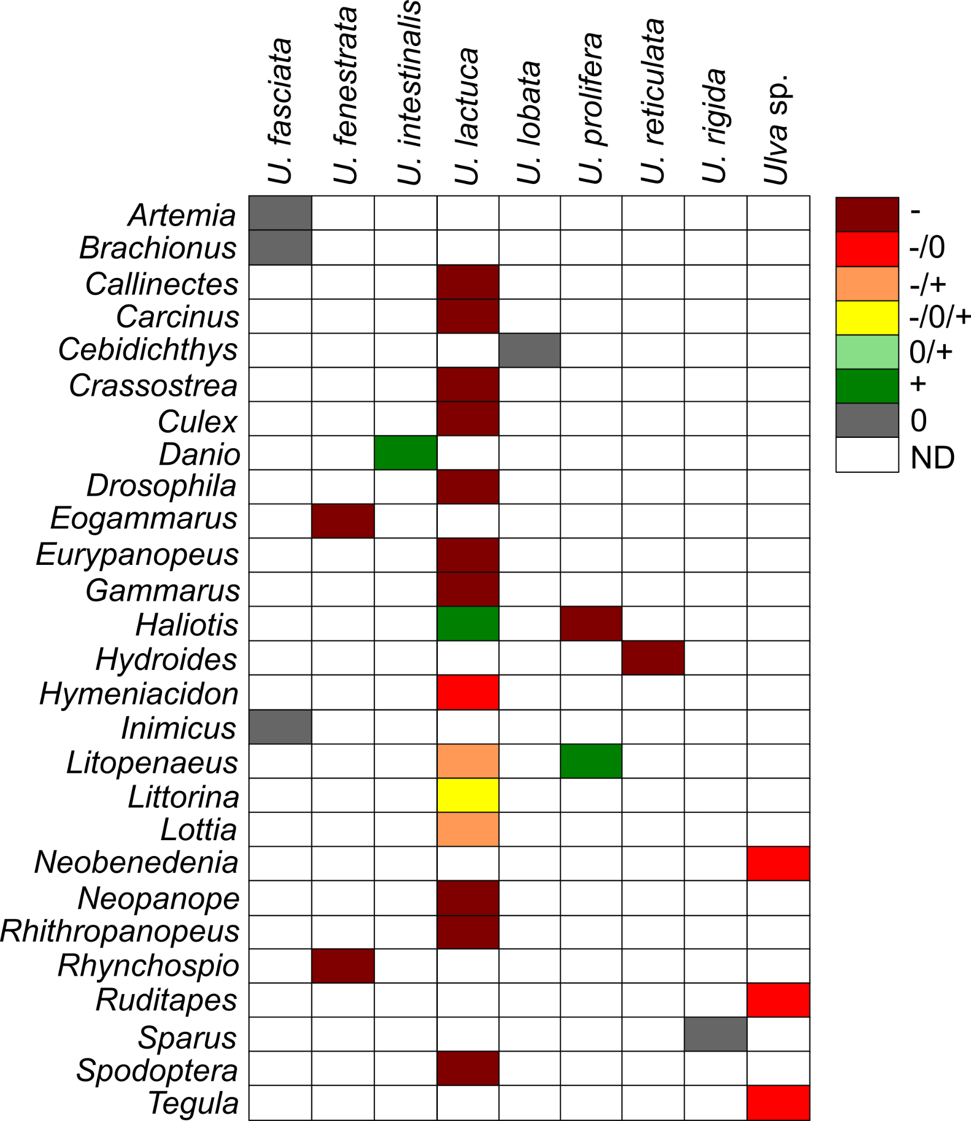

**Fig. 9.** The biological activity of *Ulva* sp. against invertebrates and vertebrates.

**6. Active compounds and secondary metabolites of *Ulva* sp.**

*Ulva* sp. harbors a diverse array of bioactive compounds, many of which have yet to be fully characterized for their potential harmful effects. The thallus of *Ulva* sp. contains amino acids such as cysteinolic acid, cysteic acid, proline, glutamic acid, and chondrine (Holdt & Kraan, 2011). It also comprises various secondary metabolites including terpenes, polyphenolic compounds, hexapeptides, diterpenoids, and steroids (Fujimura & Kajiwara, 1990; Flodin & Whitfield, 1999; Awad, 2000; Chakraborty et al., 2010a, b; Yildiz et al., 2012; Ennamany et al., 1998). Notably, taurine—an amino acid present in *Ulva* sp.—has been shown to act as a broad-spectrum cytoprotective agent (Ito & Hori, 1989; Peña-Rodríguez et al., 2011).

Moreover, *Ulva* sp. contains polyunsaturated fatty acids; extracts from *U. rigida* have demonstrated antimicrobial activity (Ismail et al., 2018). Sulphated polysaccharides, particularly ulvan—a water-soluble compound constituting approximately 8–29% of the dry weight of *Ulva*—have been noted for their anticoagulant activity through thrombin inhibition and potentiation of heparin cofactor II (Mao et al., 2006). Ulvan is also reported to possess anticancer, antiviral, hypocholesterolemic, hypolipidemic, and neuroprotective properties (Kaeffer et al., 1999; Smit, 2004; Rahimi et al., 2016; Li et al., 2017, 2018; Olasehinde et al., 2019). In contrast, Barakat et al. (2022) reported that ulvan adversely affected microalgae and certain bacterial and fungal species, such as *Klebsiella pneumoniae*, *Staphylococcus epidermidis*, *Enterococcus faecalis*, and *Candida albicans*. Additionally, studies by Alamsjah et al. (2008) indicated significant cell mortality in several microalgal taxa—caused by compounds from *U. fasciata* and *U. pertusa*—with tetraenoic acid and α-linolenic acid identified as key inhibitory agents. Lv et al. (2021) further demonstrated that hexadecanoic acid, octadecatetrienoic acid, and octadecenoic acid produced by *U. linza* induce cell death in species such as *Prorocentrum minimum* and *Platymonas helgolandica*. These findings underscore that *Ulva* sp. synthesizes a range of secondary metabolites with potent bioactivities that may have deleterious effects on various organisms.

**Table 9.**

Bioactive compounds produced by *Ulva* sp. and their biological activity on tested organisms.

|  |  |  |  |
| --- | --- | --- | --- |
| ***Ulva* species** | **Compounds** | **Activity** | **Reference** |
| *Ulva conglobata* | Sulphated polysaccharides | anticoagulation activity | Mao et al. (2006) |
| *U. rigida* | polyunsaturated fatty acids | antimicrobial activity | Ismail et al. (2018) |
| *Ulva* sp. | Taurine | cytoprotective agent | Ito and Hori (1989), Peña-Rodríguez et al. (2011) |
| *U. linza* | Hexadecanoic acid; 9Z, 12Z, 15Z-octadecatetrienoic acid; 9E-octadecenoic acid | Mortality of *Prorocentrum minimum* and *Platymonas helgolandica* | Lv et al. (2021) |
| *U. fasciata*, *U.*  *pertusa* | Octadeca-6,9,12,15-tetraenoic acid; ɑ-linolenic acid; hexadeca-4,7,10,13-tetraenoic acid | Cell mortality of *Chattonella marina*,*Chattonella antiqua*, *Fibrocapsa japonica*, *Heterosigma akashiwo*, *Heterocapsa circularisquama*, *Pyramimonas* aff. *amylifera amylifera*, *Karenia mikimotoi*, *Scrippsiella trochoidea*, *Nephroselmis astigmatica*, *Nephroselmis viridis*, *Pyramimonas parkeae*, *Oltmannsiellopsis unicellularis* | Alamsjah et al. (2005), Alamsjah et al. (2008) |
| *U. fasciata* | Ulvan- comprised of l-rhamnose, β-arabinopyranose, l-fucose, rhamnopyranose, fucopyranose, mannopyranose | Antimicrobial activity against *Klebsiella pneumonia*, *Staphylococcus epidermidis*, *Enterococcus faecali*s, and *Candida albicans* | Barakat et al. (2022) |

**7. Conclusions**

This review demonstrates that *Ulva* sp. is a globally distributed macroalga whose extensive physiological and molecular adaptations enable its widespread occurrence. Although *Ulva* sp. offers potential benefits for commercial applications such as food production, cosmetics, and bioremediation, its propensity to form massive blooms—known as Green Tides—poses significant environmental and economic challenges. The diverse methods employed to test the bioactivity of *Ulva* sp. reveal that its secondary metabolites have far-reaching inhibitory effects on heterotrophic microorganisms, microalgae, seaweeds, and even various invertebrates and vertebrates. These compounds, including amino acids, terpenes, polyphenolics, and sulphated polysaccharides, underscore the dual nature of *Ulva* sp. as both a resource and a hazardous material.

The evidence presented highlights the critical need for further interdisciplinary research to elucidate the mechanisms underlying *Ulva* sp. blooms and to develop effective management strategies. Such efforts are essential to mitigate the ecological disruptions and economic losses associated with these events, while also safeguarding human health and the integrity of marine ecosystems. Ultimately, a balanced approach that integrates advanced molecular techniques with traditional ecological assessments will be key to addressing the complex challenges posed by *Ulva* sp.

**CRediT authorship contribution statement**

**Gracjana Budzałek**: Writing – original draft, Resources, Methodology, Investigation, Data curation, Conceptualization. **Kinga Wiśniewska**: Writing – original draft, Validation, Resources, Methodology, Investigation, Data curation. **Anna Dziubińska**: Writing – original draft, Validation, Resources, Methodology, Investigation, Data curation. **Sarah Postuma**: Resources, Investigation, Data curation. **Anna Woźniak**: Resources, Investigation, Data curation. **Sylwia Śliwińska-Wilczewska**: Supervision, Project administration, Writing – original draft, Resources, Methodology, Investigation, Data curation, Funding acquisition, Conceptualization, Validation.

**Declaration of Competing Interest**

The authors declare that they have no known competing financial interests or personal relationships that could have appeared to influence the work reported in this paper.

**Acknowledgments**

This work was supported by Canada Research Chair in Phytoplankton Ecophysiology (Douglass A. Campbell from Mount Allison University, Canada) and Latitude & Light; NSERC of Canada Discovery Grant (Douglass A. Campbell from Mount Allison University, Canada), and funded by DS. 531-O500-D717-25 (S.Ś-W.) and DS. 531-O402-D031-25 (A.D.).

**Appendix A. Supporting information**

Supplementary data associated with this article can be found in the online version at:

**Data availability**

Data are available with the article at https: //github.com/FundyPhytoPhys/SynBaltic/Ulva.

**References**

Abduraup, Y. T., Diansuy, A. M., Irilis, R. A., Habibuddin, A. A., Injani, A. S., Ammang, M. A. T., Saddari, F. J., Juaini, A. A., Omandan, E. S., Guinto-Sali, M. J. Z., & Muallil, R. N. (2025). Local perceptions on the use of inorganic commercial fertilizers in eucheumatoid seaweed farming: Insights from Tawi-Tawi islands, Philippines. *Marine Policy*, *171*. https://doi.org/10.1016/j.marpol.2024.106486

Accoroni, S., Percopo, I., Cerino, F., Romagnoli, T., Pichierri, S., Perrone, C., & Totti, C. (2015). Allelopathic interactions between the HAB dinoflagellate Ostreopsis cf. ovata and macroalgae. *Harmful Algae*, *49*, 147-155.

Ahmed, S. E. A., Deyab, M. A., Afefy, A. A. M. Al, & Faiz El-Adl, M. (2021). Ulva species Blooms and its Biochemical Composition in Relation to Aquatic Environmental Properties at North Damietta-Egypt. *Scientific Journal for Damietta Faculty of Science*, *11*(1), 47–55.

Alamsjah, M.A., Hirao, S., Ishibashi, F., & Fujita, Y. (2005). Isolation and Structure Determination of Algicidal Compounds from *Ulva fasciata*. *Bioscience, Biotechnology, and Biochemistry, 69*, 2186 - 2192.

Alamsjah, M.A., Hirao, S., Ishibashi, F., Oda, T., & Fujita, Y. (2008). Algicidal activity of polyunsaturated fatty acids derived from Ulva fasciata and U. pertusa (Ulvaceae, Chlorophyta) on phytoplankton. *Journal of Applied Phycology, 20*, 713-720.

Allanson, B. R., Human, L. R. D., & Claassens, L. (2016). Observations on the distribution and abundance of a green tide along an intertidal shore, Knysna Estuary. *South African Journal of Botany*, *107*, 49–54. https://doi.org/10.1016/j.sajb.2016.02.197

Anderson, R. J., Monteiro, P. M., & Levitt, G. J. (1996). The effect of localised eutrophication on competition between Ulva lactuca (Ulvaceae, Chlorophyta) and a commercial resource of Gracilaria verrucosa (Gracilariaceae, Rhodophyta). In *Fifteenth International Seaweed Symposium: Proceedings of the Fifteenth International Seaweed Symposium held in Valdivia, Chile, in January 1995* (pp. 291-296). Springer Netherlands.

Aníbal, J., Rocha, C., & Sprung, M. (2007). Mudflat surface morphology as a structuring agent of algae and associated macroepifauna communities: A case study in the Ria Formosa. *Journal of Sea Research*, *57*(1), 36-46. https://doi.org/10.1016/j.seares.2006.07.002

Awad, N. E. (2000). Biologically active steroid from the green alga Ulva lactuca. *Phytotherapy Research: An International Journal Devoted to Pharmacological and Toxicological Evaluation of Natural Product Derivatives*, *14*(8), 641-643.

Back, S., Lehvo, A., & Back, J. B. (2000). Mass occurrence of unattached Enteromorpha intestinalis on the Finnish Baltic Sea coast. In *Ann. Bot. Fennici* (Vol. 37). Finnish Zoological and Botanical Publishing Board. https://about.jstor.org/terms

Barakat, K.M., Ismail, M.M., Abou El Hassayeb, H.E., El Sersy, N.A., & Elshobary, M.E. (2022). Chemical characterization and biological activities of ulvan extracted from Ulva fasciata (Chlorophyta). *Rendiconti Lincei. Scienze Fisiche e Naturali, 33*, 829 - 841.

Bast, F., John, A. A., & Bhushan, S. (2014). Strong endemism of bloom-forming tubular ulva in Indian west coast, with description of Ulva paschima sp. nov. (Ulvales, chlorophyta). *PLoS ONE*, *9*(10). https://doi.org/10.1371/journal.pone.0109295

Becherucci, M. E., Pereyra, P., Narvarte, M., Fanjul, E., Iribarne, O., & Martinetto, P. (2021). Tidal action and macroalgal photosynthetic activity prevent coastal acidification in an eutrophic system within a semi-desert region. *Estuarine, Coastal and Shelf Science*, *256*. <https://doi.org/10.1016/j.ecss.2021.107374>

Berdalet, E., Fleming, L. E., Gowen, R., Davidson, K., Hess, P., Backer, L. C., ... & Enevoldsen, H. (2016). Marine harmful algal blooms, human health and wellbeing: challenges and opportunities in the 21st century. *Journal of the Marine Biological Association of the United Kingdom*, *96*(1), 61–91.

Bermejo, R., Heesch, S., Mac Monagail, M., O’Donnell, M., Daly, E., Wilkes, R. J., & Morrison, L. (2019). Spatial and temporal variability of biomass and composition of green tides in Ireland. *Harmful Algae*, *81*, 94–105. https://doi.org/10.1016/j.hal.2018.11.015

Cai, H., Li, B., & Liu, C. (2011, May). The interaction between Ulva pertusa (chlorophyta) and Heterosigma akashiwo (xanthophyta) and its responses to UV-B radiation. In *2011 International Symposium on Water Resource and Environmental Protection* (Vol. 4, pp. 2575-2578). IEEE.

Cai, S. N., Zhu, H. X., Tang, Z. G., Geng, X. Y., & Sun, M. L. (2025). Complete genome sequence of Alteromonas marina OM2201, a marine bacterium degrading Ulva prolifera polysaccharides isolated from surface of the Yellow Sea. *Marine Genomics*, *80*. https://doi.org/10.1016/j.margen.2025.101168

Caniguan, M.A., Becherucci, M.E., Gastaldi, M., Narvarte, M.A. & Saad, J.F. (2025). Seawater Temperature and Tidal Action as Modulators of Ulva Spp. Micropropagules Density in a Eutrophicated Macrotidal Coastal System. *Estuaries and Coasts 48*, 80.<https://doi.org/10.1007/s12237-025-01517-0>

Chakraborty, K., Lipton, A. P., Raj, R. P., & Vijayan, K. K. (2010a). Antibacterial labdane diterpenoids of Ulva fasciata Delile from southwestern coast of the Indian Peninsula. *Food chemistry*, *119*(4), 1399-1408.

Chakraborty, K., Lipton, A. P., Paulraj, R., Chakraborty, R. D. (2010b). Guaiane sesquiterpenes from seaweed Ulva fasciata Delile and their antibacterial properties, *European Journal of Medicinal Chemistry*, *45*(6).<https://doi.org/10.1016/j.ejmech.2010.01.065>

Chapman, V. J. (1956). The marine algae of New Zealand. part I. Myxophyceae and Chlorophyceae. *Botanical Journal of the Linnean Society*, *55*(360), 333-501.

Charlier, R. H., Morand, P., & Finkl, C. W. (2008). How Brittany and Florida coasts cope with green tides. *International Journal of Environmental Studies*, *65*(2), 191-208.

Chávez-Sánchez, T., Piñón-Gimate, A., Serviere-Zaragoza, E., Sánchez-González, A., Hernández-Carmona, G., & Casas-Valdez, M. (2017). Recruitment in Ulva blooms in relation to temperature, salinity and nutrients in a subtropical bay of the Gulf of California. *Botanica Marina*, *60*(3), 257-270. https://doi.org/10.1515/bot-2016-0066

Choi, S. K., Moon, K., Kim, T., Son, Y. B., & Park, S. R. (2024). Gone with the Wind: Disappearance of Ulva-Driven Green Tides with Super Typhoons in Jeju Waters, South Korea. *Diversity*, *16*(10). https://doi.org/10.3390/d16100631

Dailer, M. L., Smith, J. E., & Smith, C. M. (2012). Responses of bloom forming and non-bloom forming macroalgae to nutrient enrichment in Hawai ‘i, USA. *Harmful Algae*, *17*, 111-125.

Den Hartog, C. (1994). Suffocation of a littoral Zostera bed by Enteromorpha radiata. *Aquatic Botany*, *47*(1), 21-28.

Dobretsov, S. V., & Qian, P. Y. (2002). Effect of bacteria associated with the green alga Ulva reticulata on marine micro-and macrofouling. *Biofouling*, *18*(3), 217-228. doi.org/10.1055/s-1999-14009

Dong, S., Xin, Y., Liu, C., Xiao, Y., Feng, X., & Liu, T. (2023). Two treatment methods on Ulva prolifera bloom result in distinctively different ecological effects in coastal environment. *Frontiers in Marine Science*, *10*. https://doi.org/10.3389/fmars.2023.1084519

Egan, S., Thomas, T., Holmström, C., & Kjelleberg, S. (2000). Phylogenetic relationship and antifouling activity of bacterial epiphytes from the marine alga Ulva lactuca: brief report. *Environmental Microbiology*, *2*(3), 343-347.

Eismann, A. I., Reis, R. P., da Silva, A. F., & Cavalcanti, D. N. (2020). Ulva spp. carotenoids: Responses to environmental conditions. *Algal research*, *48*, 101916.

Ennamany, R., Saboureau, D., Mekideche, N., & Creppy, E. E. (1998). SECMA 1®, a mitogenic hexapeptide from Ulva algeae modulates the production of proteoglycans and glycosaminoglycans in human foreskin fibroblast. *Human & experimental toxicology*, *17*(1), 18-22.

Feng, C., Xing, Y., & Wang, M. (2024). Colors of macroalgae: distinguishing Ulva prolifera and Sargassum horneri using Sentinel-2 L2A images. *IEEE Journal of Selected Topics in Applied Earth Observations and Remote Sensing*. https://doi.org/10.1109/JSTARS.2024.3519615

Flodin, C., & Whitfield, F. B. (1999). 4-Hydroxybenzoic acid: a likely precursor of 2, 4, 6-tribromophenol in Ulva lactuca. *Phytochemistry*, *51*(2), 249-255.

Fortes, M. D., & Lüning, K. (1980). Growth rates of North Sea macroalgae in relation to temperature, irradiance and photoperiod. *Helgoländer Meeresuntersuchungen*, *34*, 15-29.

Friedlander, M., Gonen, Y., Kashman, Y., & Beer, S. (1996). Gracilaria conferta and its epiphytes: 3. Allelopathic inhibition of the red seaweed by Ulva cf. lactuca. *Journal of Applied Phycology*, *8*, 21-25.

Fujimura, T., & Kajiwara, T. (1990). Production of bioflavor by regeneration from protoplasts of Ulva pertusa (Ulvales, Chlorophyta). *Hydrobiologia*, *204*, 143-149.

Gamenick, I., Jahn, A., Vopel, K., & Giere, O. (1996). Hypoxia and sulphide as structuring factors in a macrozoobenthic community on the Baltic Sea shore: colonisation studies and tolerance experiments. *Marine Ecology Progress Series*, *144*, 73-85.

Goecke, F., Labes, A., Wiese, J., & Imhoff, J. F. (2010). Chemical interactions between marine macroalgae and bacteria. *Marine ecology progress series*, *409*, 267-299.

Gong, N., Shao, K., Shen, L., Wang, Z., Han, X., Zhou, K., ... & Pan, X. (2024). How did the floating Ulva prolifera develop into the world's largest green tide?. *Marine Environmental Research*, *202*, 106763.

Granger, S., Agboga, K., Comoe, K., Fields, L., Issah, A., Koffi, M. N., . Kanakoundu, J. M. K., Nixon, S., Oczkowski, A., Sankare, Y., Schmidt, C., & Stevens, H. (2012). Determining The Origin And Ecology Of A Macroalgae (Ulva clathrata) Bloom Along The Coast Of Western Ghana And Cote d’Ivoire. *USAID Integrated Coastal and Fisheries Governance Initiative for the Western Region, Ghana. 18pp*.

Granger, S., Brush, M., Buckley, B., Traber, M., Richardson, M., & Nixon, S. W. (2000). *An Assessment of Eutrophication in Greenwich Bay*. http://seagrant.gso.uri.edu/G_Bay

Guidone, M., & Thornber, C. S. (2013). Examination of Ulva bloom species richness and relative abundance reveals two cryptically co-occurring bloom species in Narragansett Bay, Rhode Island. *Harmful Algae*, *24*, 1-9. https://doi.org/10.1016/j.hal.2012.12.007

Guiry, M.D. & Guiry, G.M. (2024). AlgaeBase. World-wide electronic publication, National University of Ireland, Galway. [https://www.algaebase.org](https://www.algaebase.org/); searched on 12 May 2024.

Harder, T., Dobretsov, S., & Qian, P. Y. (2004). Waterborne polar macromolecules act as algal antifoulants in the seaweed Ulva reticulata. *Marine Ecology Progress Series*, *274*, 133-141.

Hayden, H. S., Blomster, J., Maggs, C. A., Silva, P. C., Stanhope, M. J., & Waaland, J. R. (2003). Linnaeus was right all along: Ulva and Enteromorpha are not distinct genera. *European journal of phycology*, *38*(3), 277-294.

Herrero, J. J., Simes, D. C., Abecasis, R., Relvas, P., Garel, E., Ventura Martins, P., & Santos, R. (2023). Monitoring invasive macroalgae in southern Portugal: drivers and citizen science contribution. *Frontiers in Environmental Science*, *11*. https://doi.org/10.3389/fenvs.2023.1324600

Hofmann, L. C., Nettleton, J. C., Neefus, C. D., & Mathieson, A. C. (2010). Cryptic diversity of Ulva (Ulvales, Chlorophyta) in the Great Bay Estuarine System (Atlantic USA): introduced and indigenous distromatic species. *European Journal of Phycology*, *45*(3), 230-239.

Holdt, S. L., & Kraan, S. (2011). Bioactive compounds in seaweed: functional food applications and legislation. *Journal of applied phycology*, *23*, 543-597.

Hosny, S., El-Sheekh, M., & Labib, W. (2022). Intercellular and extracellular amino acids of different bloom species in the Mediterranean Sea Oceanological and Hydrobiological Studies Intercellular and extracellular amino acids of different bloom species in the Mediterranean Sea. *Journal Owner: Faculty of Oceanography and Geography*, *51*(2). https://doi.org/10.26881/oahs-2022.2.06

Hu, C., & He, M. X. (2008). Origin and offshore extent of floating algae in Olympic sailing area. *Eos, Transactions American Geophysical Union*, *89*(33), 302-303.

Hu, L., Hu, C., & Ming-Xia, H. E. (2017). Remote estimation of biomass of Ulva prolifera macroalgae in the Yellow Sea. *Remote Sensing of Environment*, *192*, 217-227.

Hu, Z. X., Li, T., Ge, T. T., Hu, J. W., Ping-Wang, Liu, C. Y., & Yang, G. P. (2024). Inter-annual and spatial variations of air-sea CO2 fluxes and acidification mechanism in the coastal waters of Qingdao, China during 2011–2019. *Marine Pollution Bulletin*, *209*. https://doi.org/10.1016/j.marpolbul.2024.117195

Human, L. R. D., Adams, J. B., & Allanson, B. R. (2016). Insights into the cause of an Ulva lactuca Linnaeus bloom in the Knysna Estuary. *South African Journal of Botany*, *107*, 55–62. https://doi.org/10.1016/j.sajb.2016.05.016

Ichihara, K., Arai, S., Uchimura, M., Fay, E. J., Ebata, H., Hiraoka, M., & Shimada, S. (2009). New species of freshwater Ulva, Ulva limnetica (Ulvales, Ulvophyceae) from the Ryukyu Islands, Japan. *Phycological Research*, *57*(2), 94-103.

Ismail, A., Ktari, L., Ben Redjem Romdhane, Y., Aoun, B., Sadok, S., Boudabous, A., & El Bour, M. (2018). Antimicrobial fatty acids from green alga Ulva rigida (Chlorophyta). *BioMed Research International*, *2018*.

Ito, K., & Hori, K. (1989). Seaweed: chemical composition and potential food uses. *Food reviews international*, *5*(1), 101-144.

Jin, Q., & Dong, S. (2003). Comparative studies on the allelopathic effects of two different strains of Ulva pertusa on Heterosigma akashiwo and Alexandrium tamarense. *Journal of experimental marine biology and ecology*, *293*(1), 41-55.

Jin, Q., Dong, S., & Wang, C. (2005). Allelopathic growth inhibition of Prorocentrum micans (Dinophyta) by Ulva pertusa and Ulva linza (Chlorophyta) in laboratory cultures. *European Journal of Phycology*, *40*(1), 31-37.

Jones, A. G., Quillien, N., Fabvre, A., Grall, J., Schaal, G., & Le Bris, H. (2020). Green macroalgae blooms (Ulva spp.) influence trophic ecology of juvenile flatfish differently in sandy beach nurseries. *Marine environmental research*, *154*, 104843.

Kaeffer, B., Benard, C., Lahaye, M., Blottiere, H. M. & Cherbut, C. (1999). Biological properties of ulvan, a new source of green seaweed sulfated polysaccharides, on cultured normal and cancerous colonic epithelial cells. *Planta Med.* 65, 527-531. https://doi.org/10.1055/s-1999-14009

Kang, E. J., Han, A. R., Kim, J. H., Kim, I. N., Lee, S., Min, J. O., Nam, B. R., Choi, Y. J., Edwards, M. S., Diaz-Pulido, G., & Kim, C. (2021). Evaluating bloom potential of the green-tide forming alga Ulva ohnoi under ocean acidification and warming. *Science of the Total Environment*, *769*. https://doi.org/10.1016/j.scitotenv.2020.144443

Kang, J. W., & Chung, I. K. (2017). The effects of eutrophication and acidification on the ecophysiology of Ulva pertusa Kjellman. *Journal of Applied Phycology*, *29*, 2675-2683.

Kazi, M. A., Kavale, M. G., & Singh, V. V. (2016). Morphological and molecular characterization of Ulva chaugulii sp. nov., U. lactuca and U. ohnoi (Ulvophyceae, Chlorophyta) from India. *Phycologia*, *55*(1), 45-54.

Kazir, M., Gurevich, D., Groobman, A., Prabhu, M., Israel, Á., Golberg, A., & Livney, Y. D. (2021). Physicochemical, rheological and digestibility characterization of starch extracted from the marine green macroalga Ulva ohnoi. *Food Hydrocolloids*, *120*, 106892.

Kennish, M. J., Fertig, B., & Sakowicz, G. P. (2011). Benthic Macroalgal Blooms as an Indicator of System Eutrophy in the Barnegat Bay-Little Egg Harbor Estuary. In *Bull. N.J. Acad. Sci* (Vol. 56, Issue 1). https://www.researchgate.net/publication/235354751

Krupnik, N., Paz, G. U. Y., Douek, J., Lewinsohn, E., Israel, A., Carmel, N., Mineur, F., & MaggsS, C. A. (2018). Native, invasive and cryptogenic Ulva species from the Israeli Mediterranean Sea: risk and potential. *Mediterranean Marine Science*, *19*(1), 132-146.

Lahaye, M., & Robic, A. (2007). Structure and functional properties of ulvan, a polysaccharide from green seaweeds. *Biomacromolecules*, *8*(6), 1765-1774.

Lanari, M., & Copertino, M. (2017). Drift macroalgae in the Patos Lagoon Estuary (southern Brazil): effects of climate, hydrology and wind action on the onset and magnitude of blooms. *Marine Biology Research*, *13*(1), 36–47. https://doi.org/10.1080/17451000.2016.1225957

Lee, H. W., Kang, J. C., Kim, M. S., Lee, H. W., Kang, J. C., & Kim, M. S. (2019). Taxonomy of Ulva causing blooms from Jeju Island, Korea with new species, U. pseudo-ohnoi sp. nov.(Ulvales, Chlorophyta). *Algae*, *34*(4), 253-266.

Li, W., Jiang, N., Li, B., Wan, M., Chang, X., Liu, H., Zhang, L., Yin, S., Qi, H., & Liu, S. (2018). Antioxidant activity of purified ulvan in hyperlipidemic mice. *International journal of biological macromolecules*, *113*, 971-975.

Li, Y. H., Wang, D., Xu, X. T., Gao, X. X., Sun, X., Xu, N. J. (2017). Physiological responses of a green algae (Ulva prolifera) exposed to simulated acid rain and decreased salinity. *Photosynthetica* 55, 623-629.<https://doi.org/10.1007/s11099-017-0689-0>

Lin, A. P., Wang, C., Pan, G. H., Song, L. Y., Gao, S., Xie, X. J. Wang, Z. Y., Niu, J. F., Wang, G. C. (2011). Diluted seawater promoted the green tide of Ulva prolifera (Chlorophyta, Ulvales). *Phycological Research*, *59*(4), 295-304.

Linnaeus, C. (1753). Species plantarum, exhibentes plantas rite cognitas, ad genera relatas, cum differentiis specificis, nominibus trivialibus, synonymis selectis, locis natalibus, secundum systema sexuale digestas. Vol. 2 pp. [i], 561-1200, [1-30, index], [i, err.]. Holmiae [Stockholm]: Impensis Laurentii Salvii.

Liu, F., Pang, S. J., Xu, N., Shan, T. F., Sun, S., Hu, X., & Yang, J. Q. (2010). Ulva diversity in the Yellow Sea during the large-scale green algal blooms in 2008-2009. *Phycological Research*, *58*(4), 270-279. https://doi.org/10.1111/j.1440-1835.2010.00586.x

Liu, J., Xia, Z., Zeng, Y., Xia, J., & He, P. (2025). Exploration and implication of green macroalgal proliferation in the Nanhui-east-tidal-flat: an investigation of post-reclamation mudflat wetlands. *Frontiers in Marine Science*, *12*. https://doi.org/10.3389/fmars.2025.1505586

Liu, X., Zang, Y., Fan, S., Miao, X., Fu, M., Ma, X., Li, M., Zhang, X., Wang, Z., & Xiao, J. (2024). Changes in the structure of the microbial community within the phycospheric microenvironment and potential biogeochemical effects induced in the demise stage of green tides caused by Ulva prolifera. *Frontiers in Microbiology*, *15*. https://doi.org/10.3389/fmicb.2024.1507660

Louis, J., Ballu, S., Rossi, N., Lasbleiz, M., Perrot, T., Daniel, C., Cellier, L., Hénaff, F., & Richier, S. (2023). Multi-year renewal of green tides: 18 years of algal mat monitoring (2003-2020) on French coastline (Brittany region). Marine pollution bulletin, 193, 115173.

Lü, X., Xu, H., Zhao, S., Kong, F., Yan, T., & Jiang, P. (2022). The green tide in Yingkou, China in summer 2021 was caused by a subtropical alga—Ulva meridionalis (Ulvophyceae, Chlorophyta). *Journal of Oceanology and Limnology*, *40*(6), 2354-2363.

Lv, M., Yuan, M., Wang, Y., Tang, X., & Zhao, Y. (2021). Allelopathic effects of Ulva linza on marine phytoplankton and identification of the allelochemicals. *Environmental Science and Pollution Research*, *28*(33), 45714-45723.

Malta, E., Rijstenbil, J. W., Brouwer, P. E. M., & Kromkamp, J. C. (2003). Vertical heterogeneity in physiological characteristics of Ulva spp. mats. *Marine Biology*, *143*(5), 1029-1038. https://doi.org/10.1007/s00227-003-1134-4

Malta, E.-J., & Verschuure, J. M. (1997). In Collaboration with the Netherlands Institute for Sea Research URNAL OF ’SEA RESEARCH Effects of environmental variables on between-year variation of Ulva growth and biomass in a eutrophic brackish lake. In *Journal of Sea Research* (Vol. 38).

Mantri, V. A., Kazi, M. A., Balar, N. B., Gupta, V., & Gajaria, T. (2020). Concise review of green algal genus Ulva Linnaeus. *Journal of Applied Phycology*, *32*, 2725-2741.

Mao, W., Zang, X., Li, Y., & Zhang, H. (2006). Sulfated polysaccharides from marine green algae Ulva conglobata and their anticoagulant activity. *Journal of Applied phycology*, *18*, 9-14.

Martins, I., Pardal, M. Â., Lillebo, A. I., Flindt, M. R., & Marques, J. C. (2001). Hydrodynamics as a major factor controlling the occurrence of green macroalgal blooms in a eutrophic estuary: A case study on the influence of precipitation and river management. *Estuarine, Coastal and Shelf Science*, *52*(2), 165-177. https://doi.org/10.1006/ecss.2000.0708

Melton, J.T., Collado-Vides, L., & Lopez-Bautista, J. M. (2016). Molecular identification and nutrient analysis of the green tide species Ulva ohnoi M. Hiraoka & S. Shimada, 2004 (Ulvophyceae, Chlorophyta), a new report and likely nonnative species in the Gulf of Mexico and Atlantic Florida, USA. Aquatic Invasions, 11, 225-237.

Ménesguen, A., Perrot, T., & Dussauze, M. (2010). Ulva mass accumulations on Brittany beaches: explanation and remedies deduced from models. *Mercator Ocean Quartely Newsletter*, *38*, 4-13.

Ménesguen, A., Cugier, P., & Leblond, I. (2006). A new numerical technique for tracking chemical species in a multisource, coastal ecosystem applied to nitrogen causing Ulva blooms in the Bay of Brest (France). *Limnology and Oceanography*, *51*(1 II), 591–601. <https://doi.org/10.4319/lo.2006.51.1_part_2.0591>

Montgomery, R. L., Ford, A. W., Poindexter, M. E., & Bartos, M. K. (1978). Guidelines for dredged material disposal area reuse management. *Dredged Material Res. Pgm. Tech. Rept.* DS-78-12. U.S. Army Corps of Engineers Waterways Experiment Station, Vicksburg, Miss.

Munda, I. M. (1993). Changes and degradation of seaweed stands in the Northern Adriatic. *Hydrobiologia*, *260*, 239-253.

Mutizabal-Aros, J., Meynard, A., & Contreras-Porcia, L. (2024a). A Physiological Analysis of Desiccation Stress in the Green Tide Species Ulva stenophylloides and Ulva uncialis in the South Pacific. *Journal of Marine Science and Engineering*, *12*(11), 1893. https://doi.org/10.3390/jmse12111893

Mutizabal-Aros, J., Ramírez, M. E., Haye, P. A., Meynard, A., Pinilla-Rojas, B., Núñez, A., Latorre-Padilla, N., Search, F. V., Tapia, F. J., Saldías, G. S., Navarrete, S. A., & Contreras-Porcia, L. (2024b). Morphological and Molecular Identification of Ulva spp. (Ulvophyceae; Chlorophyta) from Algarrobo Bay, Chile: Understanding the Composition of Green Tides. *Plants*, *13*(9). https://doi.org/10.3390/plants13091258

Nan, C., Zhang, H., Lin, S., Zhao, G., & Liu, X. (2008). Allelopathic effects of Ulva lactuca on selected species of harmful bloom-forming microalgae in laboratory cultures. *Aquatic Botany*, *89*(1), 9-15.

Nelson, T. A., Nelson, A. V., & Tjoelker, M. (2003). Seasonal and Spatial Patterns of "Green Tides" (Ulvoid Algal Blooms) and Related Water Quality Parameters in the Coastal Waters of Washington State, USA.

Norkko, J., Bonsdorff, E., & Norkko, A. (2000). Drifting algal mats as an alternative habitat for benthic invertebrates:: Species specific responses to a transient resource. *Journal of experimental marine biology and ecology*, *248*(1), 79-104.

Olasehinde, T. A., Olaniran, A. O., & Okoh, A. I. (2019). Macroalgae as a valuable source of naturally occurring bioactive compounds for the treatment of Alzheimer’s disease. *Marine drugs*, *17*(11), 609.

Olyarnik, S. V., & Stachowicz, J. J. (2012). Multi-year study of the effects of Ulva sp. blooms on eelgrass Zostera marina. *Marine Ecology Progress Series*, *468*, 107-117.

Park, H. J., Byeon, S. Y., Park, S. R., & Lee, H. J. (2022). Temporal variation in the community structure of green tide forming macroalgae (Chlorophyta; genus Ulva) on the coast of Jeju Island, Korea based on DNA barcoding. *Korean Journal of Environmental Biology*, *40*(4), 464-476.

Peña-Rodríguez, A., Mawhinney, T. P., Ricque-Marie, D., & Cruz-Suárez, L. E. (2011). Chemical composition of cultivated seaweed Ulva clathrata (Roth) C. Agardh. *Food chemistry*, *129*(2), 491-498.

Peter, N. R., Raja, N. R., Rengarajan, J., Radhakrishnan Pillai, A., Kondusamy, A., Saravanan, A. K., Changaramkumarath Paran, B., & Kumar Lal, K. (2024). A comprehensive study on ecological insights of Ulva lactuca seaweed bloom in a lagoon along the southeast coast of India. *Ocean and Coastal Management*, *248*. https://doi.org/10.1016/j.ocecoaman.2023.106964

Provasoli, L., & Pintner, I. J. (1980). Bacteria induced polymorphism in an axenic laboratory strain of Ulva lactuca (Chlorophyceae) 1. *Journal of phycology*, *16*(2), 196-201.

Puppin-Gonçalves, C. T., de Medeiros, L. L. L., Lopes, P. F. M., & de Morais Freire, F. A. (2024). Ulva lactuca blooms through the eyes of fishers: Threats to vulnerable coastal communities. *Marine Pollution Bulletin*, *208*, 117038.

Qi, L., Hu, C., Xing, Q., & Shang, S. (2016). Long-term trend of Ulva prolifera blooms in the western Yellow Sea. *Harmful Algae*, *58*, 35–44. https://doi.org/10.1016/j.hal.2016.07.004

Raffaelli, D., Conacher, A., McLachlan, H., & Emes, C. (1989). The role of epibenthic crustacean predators in an estuarine food web. *Estuarine, Coastal and Shelf Science*, *28*(2), 149-160.

Rahimi, F., Tabarsa, M., & Rezaei, M. (2016). Ulvan from green algae Ulva intestinalis: Optimization of ultrasound-assisted extraction and antioxidant activity. *Journal of Applied Phycology*, *28*, 2979-2990.

Ramus, J., Beale, S. I., Mauzerall, D., & Howard, K. L. (1976). Changes in photosynthetic pigment concentration in seaweeds as a function of water depth. *Marine Biology*, *37*, 223-229.

Renjun, W., You, W., Jing, Z., Junhua, S., & Xuexi, T. (2013). Algicidal activity of Ulva pertusa and Ulva prolifera on Prorocentrum donghaiense under laboratory conditions. *African Journal of Microbiology Research*, *7*(34), 4389-4396.

Runca, E., Bernstein, A., Postma, L., & Di Silvio, G. (1996). Control of macroalgae blooms in the Lagoon of Venice. Ocean & coastal management, 30(2-3), 235-257.

Rybak, A. S. (2015). Revision of herbarium specimens of freshwater Enteromorpha-like Ulva (Ulvaceae, Chlorophyta) collected from Central Europe during the years 1849–1959. *Phytotaxa*, *218*(1), 001-029.

Rybak, A. S., & Gąbka, M. (2018). The influence of abiotic factors on the bloom-forming alga Ulva flexuosa (Ulvaceae, Chlorophyta): possibilities for the control of the green tides in freshwater ecosystems. *Journal of Applied Phycology*, *30*(2), 1405-1416. https://doi.org/10.1007/s10811-017-1301-5

Rzymski, P., Niedzielski, P., Kaczmarek, N., Jurczak, T., & Klimaszyk, P. (2015). The multidisciplinary approach to safety and toxicity assessment of microalgae-based food supplements following clinical cases of poisoning. *Harmful Algae*, *46*, 34-42.

Salama, M., Metwally, A. F. K., Nasser, A. W., & Taha, H. M. (2021). Biointerference relationship between the macroalga Ulva lactuca and two green microalgae. *The Egyptian Journal of Aquatic Research*, *47*(2), 163-169.

Samanta, P., Shin, S., Jang, S., Song, Y. C., Oh, S., & Kim, J. K. (2019). Stable carbon and nitrogen isotopic characterization and tracing nutrient sources of Ulva blooms around Jeju coastal areas. *Environmental Pollution*, *254*. https://doi.org/10.1016/j.envpol.2019.113033

Sfriso, A., Pavoni, B., & Marcomini, A. (1989). Macroalgae And Phytoplankton Standing Crops In The Central Venice Lagoon: Primary Production And Nutrient Balance. In *The Science of the Total Environment* (Vol. 80).

Shi, X., Qi, M., Tang, H., & Han, X. (2015). Spatial and temporal nutrient variations in the Yellow Sea and their effects on Ulva prolifera blooms. *Estuarine, Coastal and Shelf Science* *163*, Part A, 36-43.<https://doi.org/10.1016/j.ecss.2015.02.007>.

Shimada, S., Hiraoka, M., Nabata, S., Iima, M., & Masuda, M. (2003). Molecular phylogenetic analyses of the Japanese Ulva and Enteromorpha (Ulvales, Ulvophyceae), with special reference to the free‐floating Ulva. *Phycological research*, *51*(2), 99-108.

Simon, C., McHale, M., & Sulpice, R. (2022). Applications of Ulva biomass and strategies to improve its yield and composition: a perspective for Ulva aquaculture. *Biology, 11*(11), 1593.

Smetacek, V., & Zingone, A. (2013). Green and golden seaweed tides on the rise. *Nature*, *504*(7478), 84-88.

Smit, A. J. (2004). Medicinal and pharmaceutical uses of seaweed natural products: A review. *Journal of applied phycology*, *16*(4), 245-262.

Spoerner, M., Wichard, T., Bachhuber, T., Stratmann, J., & Oertel, W. (2012). Growth and thallus morphogenesis of Ulva mutabilis (Chlorophyta) depends on a combination of two bacterial species excreting regulatory factors. *Journal of Phycology*, *48*(6), 1433-1447.

Su, C-Y., Fontana, S., & Liu, S-L. (2024). Unforeseen green tide of floating tubular *Ulva meridionalis*, a lethal threat to oyster farming, along the west coast of Taiwan: tracking its origin and ecophysiological insights. *Botanica Marina*, *68*(1), 5-20.<https://doi.org/10.1515/bot-2024-0006>

Sun, X., Xia, Y. M., & Xu, N. J. (2012). Allelopathic effects of *Enteromorpha intestinalis* (Ulvaceae, Chlorophyta) on *Prorocentrum micans* (Prorocentraceae, Dinophyta). *Allelopathy Journal*, *30*(2), 299-310.

Tang, Y. Z., & Gobler, C. J. (2011). The green macroalga, Ulva lactuca, inhibits the growth of seven common harmful algal bloom species via allelopathy. *Harmful Algae*, *10*(5), 480-488.

Teichberg, M., Fox, S. E., Olsen, Y. S., Valiela, I., Martinetto, P., Iribarne, O., Muto, E. Y., Petti, M. A. V., Corbisier, T. N., Soto-Jiménez, M, Páez-Osuna, F., Castro, P., Freitas, H., Zitelli, A., Cardinaletti, M., & Tagliapietra, D. (2010). Eutrophication and macroalgal blooms in temperate and tropical coastal waters: nutrient enrichment experiments with Ulva spp. *Global Change Biology*, *16(*9), 2624-2637.

Tujula, N. A. (2006). *Analysis of the epiphytic bacterial community associated with the green alga Ulva australis* (Doctoral dissertation, UNSW Sydney).

Uchimura, M, Yoshida, G., Hiraoka, M., Komatsu, T., Arai, S., & Terawaki, T. (2004). Ecological studies of green tide, Ulva spp. (Chlorophyta) in Hiroshima Bay, the Seto Inland Sea. *Jpn J Phycol* 52(Suppl):17-22

Valiela, I., McClelland, J., Hauxwell, J., Behr, P. J., Hersh, D., & Foreman, K. (1997). Macroalgal blooms in shallow estuaries: controls and ecophysiological and ecosystem consequences. *Limnology and Oceanography, 42*(5 part 2), 1105-1118.

Van Alstyne, K. L., Nelson, T. A., & Ridgway, R. L. (2015). Environmental chemistry and chemical ecology of “green tide” seaweed blooms. *Integrative and Comparative Biology*, *55*(3), 518-532.

van Beukering, P., & Cesar, H. S. (2004). Ecological economic modeling of coral reefs: Evaluating tourist overuse at Hanauma Bay and algae blooms at the Kihei Coast, Hawai'i. *Pacific Science*, *58*(2), 243-260.

Viaroli, P., Bartoli, M., Azzoni, R., Giordani, G., Mucchino, C., Naldi, M., Nizzoli, D., & Tajé, L. (2005). Nutrient and iron limitation to Ulva blooms in a eutrophic coastal lagoon (Sacca di Goro, Italy). *Hydrobiologia*, *550*(1), 57–71. https://doi.org/10.1007/s10750-005-4363-3

Viaroli, P., Giordani, G., Bartoli, M., Naldi, M., Azzoni, R., Nizzoli, D., Ferrari, I., Zaldı´var Comenges, J. M., Bencivelli, S., Castaldelli, G., & Fano, E. A. (2005a). The Sacca di Goro lagoon and an arm of the Po River. In P.J. Wangersky (ed), The Handbook of Environmental Chemistry, Volume 5. Water Pollution: Estuaries. Springer-Verlag

Villares, R., Puente, X., & Carballeira, A. (1999). Nitrogen and phosphorus in Ulva sp. in the Galician Rias Bajas (northwest Spain): Seasonal fluctuations and influence on growth. *Boletin-Instituto Español de Oceanografia*, *15*(1/4), 337-342.

Wan, A. H., Wilkes, R. J., Heesch, S., Bermejo, R., Johnson, M. P., & Morrison, L. (2017). Assessment and characterisation of Ireland's green tides (Ulva species). *PLoS One*, *12*(1), e0169049.

Wang, Q., Dong, S., Tian, X., & Wang, F. (2007). Effects of circadian rhythms of fluctuating temperature on growth and biochemical composition of Ulva pertusa. *Hydrobiologia*, *586*, 313-319.

Wang, R. J., Xiao, H., Zhang, P. Y., Qu, L., Cai, H. J., & Tang, X. X. (2006). Comparative studies on the allelopathic effects of Ulva pertusa Kjellml, Corallina pilulifera Postl et Ruprl, and Sargassum thunbergii Mertl O. Kuntze on Skeletonema costatum (Grev.) Cleve. *Journal of Integrative Plant Biology*, *48*(12), 1415-1423.

Wang, R., Feng, L., Tang, X., Wang, J., & Dong, S. (2012). Allelopathic growth inhibition of Heterosigma akashiwo by the three Ulva spcieces (Ulva Pertusa, Ulva Linza, Enteromorpha intestinalis) under laboratory conditions. *Acta Oceanologica Sinica*, *31*(3), 138-144.

Wichard, T., Charrier, B., Mineur, F., Bothwell, J. H., Clerck, O. D., & Coates, J. C. (2015). The green seaweed Ulva: a model system to study morphogenesis. *Frontiers in plant science*, *6*, 123849.

Worm, B., Lotze, H. K., & Sommer, U. (2001). Algal propagule banks modify competition, consumer and resource control on Baltic rocky shores. *Oecologia*, *128*, 281-293

Wu, H., Liu, Y., Beardall, J., Zhong, Z., Gao, G., & Xu, J. (2022). Physiological acclimation of Ulva prolifera to seasonal environmental factors drives green tides in the Yellow Sea. Marine Environmental Research 179, 105695. https://doi.org/10.1016/j.marenvres.2022.105695

Xia, Z., Yang, Y., Zeng, Y., Sun, Y., Cui, Q., Chen, Z., Liu, J., Zhang, J., & He, P. (2024). Temporal succession of micropropagules during accumulation and dissipation of green tide algae: A case study in Rudong coast, Jiangsu Province. *Marine Environmental Research*, *202*, 106719.

Xing, Q., Kim, S. J., & Yarish, C. (2024). Environmental DNA Detection in Marine Macrophyte Ecosystems as a Potential Blue Carbon Source in Sediments. *Coasts*, *4*(4), 687-696. https://doi.org/10.3390/coasts4040036

Xu, D., Gao, Z., Zhang, X., Fan, X., Wang, Y., Li, D., Wang, W., Zhuang, Z., & Ye, N. (2012). Allelopathic interactions between the opportunistic species *Ulva prolifera* and the native macroalga *Gracilaria lichvoides*. *Plos one*, *7*(4), e33648.

Xu, Q., Zhang, H., Ju, L., & Chen, M. (2014). Interannual variability of Ulva prolifera blooms in the Yellow Sea. *International Journal of Remote Sensing*, *35*(11-12), 4099-4113. https://doi.org/10.1080/01431161.2014.916052

Yabe, T., Ishii, Y., Amano, Y., Koga, T., Hayashi, S., Nohara, S., & Tatsumoto, H. (2009). Green tide formed by free-floating Ulva spp. at Yatsu tidal flat, Japan. *Limnology*, *10*(3), 239–245. https://doi.org/10.1007/s10201-009-0278-4

Ye, N. H., Zhang, X. W., Mao, Y. Z., Liang, C. W., Xu, D., Zou, J., Zhuang, Z. M. & Wang, Q. Y. (2011). ‘Green tides’ are overwhelming the coastline of our blue planet: taking the world’s largest example. *Ecological Research*, *26*, 477-485.

Yildiz, G., Celikler, S., Vatan, O., & Dere, S. (2012). Determination of the anti-oxidative capacity and bioactive compounds in green seaweed Ulva rigida C. Agardh. *International Journal of Food Properties*, *15*(6), 1182-1189.

Yoshida, G., Uchimura, M., & Hiraoka, M. (2015). Persistent occurrence of floating Ulva green tide in Hiroshima Bay, Japan: seasonal succession and growth patterns of Ulva pertusa and Ulva spp. (Chlorophyta, Ulvales). *Hydrobiologia*, *758*(1), 223-233. https://doi.org/10.1007/s10750-015-2292-3

Zhang, H., Qin, Q., Sun, D., Ye, X., Wang, S., & Zong, Z. (2024). Automatic Detection of Floating Ulva prolifera Bloom from Optical Satellite Imagery. *Journal of Marine Science and Engineering*, *12*(4). https://doi.org/10.3390/jmse12040680

Zhang, Y., He, P., Li, H., Li, G., Liu, J., Jiao, F., Zhang, J., Huo, Y., Shi, X., Su, R., Ye, N., Liu, D., Yu, R., Wang, Z., Zhou, M., & Jiao, N. (2019). Ulva prolifera green-tide outbreaks and their environmental impact in the Yellow Sea, China. In *National Science Review* (Vol. 6, Issue 4, pp. 825-838). Oxford University Press. https://doi.org/10.1093/nsr/nwz026